**SMART PRESCRIPTION APPLICATION**

Software Requirement Specification

By

|  |  |  |
| --- | --- | --- |
| Mr. Natthakan | Kaeokanpai | 552115020 |
| Mr. Phithiwat | Sitthitun | 552115051 |

Department of Software Engineering College of Arts, Media and Technology Chiang Mai University

Project Advisor

Dr.Prompong Sugunnasil

**Document Story**

|  |  |  |  |  |  |  |  |  |  |  |  |  |  |  |  |  |  |  |  |  |
| --- | --- | --- | --- | --- | --- | --- | --- | --- | --- | --- | --- | --- | --- | --- | --- | --- | --- | --- | --- | --- |
|  | **Document**  **Name** |  |  | **Version** |  |  | **Status** |  |  | **Date** |  |  | **Viewable** |  |  | **Editable** |  |  | **Responsible** |  |
|  | | |  | | |  | | |  | | |  | | |  | | |
|  | | |
| **Documents** | | | | | | | | | | | | | | | | | | | | |
| Software  Requirement Specification_ V.0.1 | | | - Add  Chapter One  Introduction  - Add Chapter Two Overall Description  - Add  Chapter Three Functional Requirement  - Add  Chapter Four Specific Requirement | | | Reviewed | | | June  10th  2016 | | | NAT,PHI,  PROM | | | NAT,PHI | | | NAT,PHI | | |
| Software  Requirement  Specification_ V.1.0 | | | - Update  Chapter One  Introduction  - Update  Chapter Two Overall Description  - Update  Chapter  Three Functional Requirement  - Update  Chapter Four  Specific  Requirement  - Add Chapter Five Reference | | | Released | | | July  20th  2016 | | | NAT,PHI,  PROM | | | NAT,PHI | | | NAT,PHI | | |
| Software  Requirement Specification_ V.2.0 | | | - Update  Chapter One  Introduction  - Update Chapter Two Overall Description  - Update  Chapter | | | Released | | | July  30th  2016 | | | NAT,PHI,  PROM | | | NAT,PHI | | | NAT,PHI | | |

|  |  |  |  |  |  |  |  |  |
| --- | --- | --- | --- | --- | --- | --- | --- | --- |
|  | **Document Name** | SMART-PRESCRIPTION-  APPLICATION- [SRS_V3.0] |  | **Owner** | Natthakan Kaeokanpai,  Phithiwat Sitthitun |  | **Page** | 2 |
|  | |  | |  | |
|  | **Document Type** | Software Requirement  Specification |  | **Release**  **Date** | August 26th, 2016 |  | **Print Date** | December 9th, 2016 |
|  | |  | |
|  | |

|  |  |  |  |  |  |  |
| --- | --- | --- | --- | --- | --- | --- |
|  | Three  Functional  Requirement  - Update  Chapter Four Specific Requirement  - Update  Chapter Five  Reference |  |  |  |  |  |
| Software  Requirement Specification_ V.2.0 | - Update  Chapter One  Introduction  - Update  Chapter Two Overall Description  - Update  Chapter  Three Functional Requirement  - Update  Chapter Four  Specific  Requirement | Released | August 26th  2016 | NAT,PHI,  PROM | NAT,PHI | NAT,PHI |

*Acronym*

NAT = Natthakan Kaeokanpai PHI = Phithiwat Sitthitun PROM = Prompong Sugunnasil

|  |  |  |  |  |  |
| --- | --- | --- | --- | --- | --- |
| **Document Name** | SMART-PRESCRIPTION-  APPLICATION- [SRS_V3.0] | **Owner** | Natthakan Kaeokanpai,  Phithiwat Sitthitun | **Page** | 3 |
| **Document Type** | Software Requirement  Specification | **Release**  **Date** | August 26th, 2016 | **Print Date** | December 9th, 2016 |

**Table of content**

Chapter One | Introduction...................................................................................................................... 5

1.1 Objective ....................................................................................................................................... 5

1.2 Project Scope ................................................................................................................................ 5

1.3 Acronyms and Definitions ............................................................................................................ 5

Chapter Two | Overall Description ......................................................................................................... 6

2.1 Product Perspective....................................................................................................................... 6

2.2 Product Features............................................................................................................................ 6

2.3 User Classes and Characteristics................................................................................................... 6

2.4 Operation Environment................................................................................................................. 6

Chapter Three | Functional Requiremen ................................................................................................. 7

3.1 User Requirement Specification ................................................................................................... 7

3.2 User Requirement Specification with the Software Requirement Specification .......................... 9

Chapter Four | Specific Requirement .................................................................................................... 19

4.1 Use Case Scenarios ..................................................................................................................... 20

4.2 Use Case Description .................................................................................................................. 25

Chapter Five | References ..................................................................................................................... 69

|  |  |  |  |  |  |
| --- | --- | --- | --- | --- | --- |
| **Document Name** | SMART-PRESCRIPTION-  APPLICATION- [SRS_V3.0] | **Owner** | Natthakan Kaeokanpai,  Phithiwat Sitthitun | **Page** | 4 |
| **Document Type** | Software Requirement  Specification | **Release**  **Date** | August 26th, 2016 | **Print Date** | December 9th, 2016 |

**Chapter One | Introduction**

**1.1 Objective**

The objective of the Software Design Document for “Smart prescription application” both Android mobile application and web application are to provide a description and explain of the design system including activity following requirements specification and before programming. This document is based on the project proposal, project plan and software requirement specification and help developers to understand how to work for this application.

**1.2 Project Scope**

Smart prescription application consists of a web application and a mobile application. Smart prescription application requires a web application for creating a patient‘s profile and allergy report by a doctor and the Smart prescription application require a mobile application to generate and scan the QR code on a mobile phone by a pharmacist.

The features of the web application consist of:

Feature#1: Prescription system

Feature#2: Account management system

Feature#3: Authentication system

Feature#5: Report allergy system

Feature#6: Allergy drug summary report system

The features of the mobile application consist of:

Feature#4: Prescription verification system

|  |  |  |  |  |  |
| --- | --- | --- | --- | --- | --- |
| **Document Name** | SMART-PRESCRIPTION-  APPLICATION- [SRS_V3.0] | **Owner** | Natthakan Kaeokanpai,  Phithiwat Sitthitun | **Page** | 5 |
| **Document Type** | Software Requirement  Specification | **Release**  **Date** | August 26th, 2016 | **Print Date** | December 9th, 2016 |

**Chapter Two | Overall Description**

**2.1 Product Perspective**

Smart prescription application can create the prescription of the patient in form of QR code that creates by a doctor. Smart prescription application requires a mobile application for scan QR code by the pharmacist. Pharmacist can get the prescription of patient with the detail of drug on a mobile application.

Smart prescription application can also record the history of allergy drug of patient and report to the Food and Drug Administration, Ministry of Public Health organization or (FDA) for observing unusually allergy drug that has been found in Thailand.

**2.2 Product Features**

From the architecture of our project with schedule we separated the whole project of develops application according to this. The description is shown below:

Feature#1: Prescription system

Feature#2: Account management system

Feature#3: Authentication system

Feature#4: Verification system

Feature#5: Allergy report system

Feature#6: Summary allergy report system

**2.3 User Classes and Characteristics**

The intended users for this application. The doctor have to know about using basic of webapplication. The pharmacists have to know basic of how to use android application to scan QR code to export the information of patient’s profile.

**2.4 Operation Environment**

- Internet

- Laptops

1. Dell inspiron 5220

Processor: Intel Core i5 3210M (3.1 GHz) Processor Memory: 8GB DDR3

Memory Hard Disk: 1000GB

Operating System: Window 7 Home Basic

2. Asus X550DP-DS101

AMD A-Series A10-5750M (2.50GHz) 8GB Memory 1TB

HDD AMD Radeon

Windows 8 64-Bit

- Mobile phone: Android Operating System with camera

1. Asus zenfone 4.5

Android 4.4.2 (KitKat)

Processor: Intel Atom Z2520DualCore

CPU Speed: 1.2 GHz Memory 8GB (Internal) RAM 1GB

2. Samsung galaxy J7

OS: Android OS, v5.1 (Lollipop)

Processor: Quad-core 1.4 GHz Cortex-A53 & quad-core 1.0 GHz Cortex-A53

Octa-core 1.5 GHz

Memories 16 GB, 1.5 GB RAM 8GB (Internal)

|  |  |  |  |  |  |
| --- | --- | --- | --- | --- | --- |
| **Document Name** | SMART-PRESCRIPTION-  APPLICATION- [SRS_V3.0] | **Owner** | Natthakan Kaeokanpai,  Phithiwat Sitthitun | **Page** | 6 |
| **Document Type** | Software Requirement  Specification | **Release**  **Date** | August 26th, 2016 | **Print Date** | December 9th, 2016 |

**Chapter Three | Functional Requiremen**t

**3.1 User Requirement Specification**

**Feature #1 Prescription system**

URS-01: Doctors can view a doctor home page on the web application.

URS-02: Doctors can create a patient’s profile on the web application by inputting personal id, name, surname, prescription and username.

URS-03: Doctors can update a patient’s profile on the web application by application by input personal id, name, surname, prescription or username.

URS-04: Doctors can delete a patient’s profile on the web application.

URS-05: Doctors can search patient’s profiles on the web application by using personal id, name, or surname.

URS-06: Doctors can view a patient’s profile on the web application.

URS-07: Doctors can view list of patient’s profiles on the web application.

**Feature #2 Account management system**

URS-08: Administrators can view an admin home page on the web application.

URS-09: Administrators can create a user’s profile on the web application by inputting name, surname, username, password, confirm-password and position.

URS-10: Administrators can update a user’s profile on the web application by inputting name,

surname, username, password, confirm-password or position.

URS-11: Administrators can delete a user’s profile on the web application.

URS-12: Administrators can search a user’s profile on the web application by using name, surname, or username.

URS-13: Administrators can view a user’s profile on the web application.

URS-14: Administrators can view list of user’s profile on the web application.

**Feature #3 Authentication system**

URS-15: Doctors, Administrations, and FDAs can login to the web application by using username and password.

URS-16: Doctors, Administrations, and FDAs can logout from the web application.

URS-17: Patients can login to the mobile application by using username and password.

URS-18: Patients can logout from the mobile application.

**Feature#4 Verification system**

URS-19: Patients can view the QR code on the mobile application.

URS-20: Pharmacists can scan the QR code on the mobile application.

URS-21: Pharmacists can add the time of dispensation to the patient’s profile on the mobile application.

|  |  |  |  |  |  |
| --- | --- | --- | --- | --- | --- |
| **Document Name** | SMART-PRESCRIPTION-  APPLICATION- [SRS_V3.0] | **Owner** | Natthakan Kaeokanpai,  Phithiwat Sitthitun | **Page** | 7 |
| **Document Type** | Software Requirement  Specification | **Release**  **Date** | August 26th, 2016 | **Print Date** | December 9th, 2016 |

**Feature#5 Allergy report system**

URS-01: Doctors can view a doctor home page on the web application.

URS-22: Doctors can create an allergy report on the web application by inputting personal id, name, surname, and allergy drug.

URS-23: Doctors can update an allergy report on the web application by inputting personal id, name, surname, or allergy drug.

URS-24: Doctors can delete an allergy report on the web application.

URS-25: Doctors can search an allergy report on the web application by using personal id, name, or surname.

URS-26: Doctors can view an allergy drug report on the web application.

URS-27: Doctors can view list of allergy drug reports on the web application.

**Feature#6 Summary allergy report system**

URS-28: FDAs can view a FDA home page on the web application.

URS-29: FDAs can view an allergy report on the web application.

URS-30: FDAs can view list of allergy reports on the web application.

|  |  |  |  |  |  |
| --- | --- | --- | --- | --- | --- |
| **Document Name** | SMART-PRESCRIPTION-  APPLICATION- [SRS_V3.0] | **Owner** | Natthakan Kaeokanpai,  Phithiwat Sitthitun | **Page** | 8 |
| **Document Type** | Software Requirement  Specification | **Release**  **Date** | August 26th, 2016 | **Print Date** | December 9th, 2016 |

**3.2 User Requirement Specification with the Software**

**Requirement Specification**

**URS-01: Doctors can view a doctor home page on the web application.**

SRS-001: The system shall provide menu bars (home, and logout).

SRS-002: The system shall provide patient options menu box (create patient and manage patient) and allergy options menu box (create allergy report and manage allergy reports).

SRS-003: The system shall display information of current doctor which includes position, name, surname and username.

**URS-02: Doctors can create a patient’s profile on the web application by inputting personal id, name, surname, prescription and username.**

SRS-001: The system shall provide menu bars (home, and logout).

SRS-004: The system shall provide the breadcrumb link.

SRS-005: The system shall provide patient create form to allow to doctor input information which includes personal ID, name, surname, prescription, and username.

SRS-006: The system shall display error message “Personal ID cannot be blank.” when doctors do not

input personal ID.

SRS-007: The system shall display error message “Personal ID has already been exist.” when doctors input personal ID that exist in the database.

SRS-008: The system shall display error message “Personal ID is invalid” when doctors input wrong personal Id.

SRS-009: The system shall display error message “Name cannot be blank.” when doctors do not input name.

SRS-010: The system shall display error message “Surname cannot be blank.” when doctors do not

input surname.

SRS-011: The system shall display error message “Prescription cannot be blank.” when doctors do not input prescription.

SRS-012: The system shall display error message “Username cannot be blank.” when doctors do not

input username.

SRS-013: The system shall display error message “Username has already been taken. Please change.”

when doctors input username that repeated with the database.

SRS-014: The system shall display error message “Name is invalid.” when doctors input name with not a letter on English language.

SRS-015: The system shall display error message “Surname is invalid.” when doctors input surname with not a letter on English language.

SRS-016: The system shall provide a ‘Create’ button for creating patient’s profiles.

SRS-019: The system shall validate personal id, name, surname, prescription, and username by Ajax validation.

SRS-017: The system shall generate the password to a patient’s profile, which is 5 digits number.

SRS-018: The system shall store doctor’s id, and date time of creating profile into the database when

doctors click ‘Create’ button.

SRS-020: The system shall save data of patient’s profiles to database and redirect user to patient’s

profile UI.

|  |  |  |  |  |  |
| --- | --- | --- | --- | --- | --- |
| **Document Name** | SMART-PRESCRIPTION-  APPLICATION- [SRS_V3.0] | **Owner** | Natthakan Kaeokanpai,  Phithiwat Sitthitun | **Page** | 9 |
| **Document Type** | Software Requirement  Specification | **Release**  **Date** | August 26th, 2016 | **Print Date** | December 9th, 2016 |

**URS-03: Doctors can update a patient’s profile on the web application by inputting personal id, name, surname, prescription or username.**

SRS-001: The system shall provide menu bars (home, and logout).

SRS-004: The system shall provide the breadcrumb link.

SRS-021: The system shall provide the manage page, which includes create button, search text field, search button.

SRS-022: The system shall provide the table lists of patient which include seven columns (no.,

personal ID, name, surname, responsible, create date and options.)

SRS-023: The system shall provide ‘Update’ button () in the options column of table. SRS-024: The system shall retrieve patient’s profiles from database.



SRS-025: The system shall provide patient update profiles form that has default information (personal

ID, name, surname, prescription, and username).

SRS-006: The system shall display error message “Personal ID cannot be blank.” when doctors do not input personal ID.

SRS-007: The system shall display error message “Personal ID has already been exist.” when doctors

input personal ID that exist in the database.

SRS-008: The system shall display error message “Personal ID is invalid” when doctors input wrong personal Id.

SRS-009: The system shall display error message “Name cannot be blank.” when doctors do not input

name.

SRS-010: The system shall display error message “Surname cannot be blank.” when doctors do not input surname.

SRS-011: The system shall display error message “Prescription cannot be blank.” when doctors do not input prescription.

SRS-012: The system shall display error message “Username cannot be blank.” when doctors do not input username.

SRS-013: The system shall display error message “Username has already been taken. Please change.”

when doctors input username that repeated with the database.

SRS-014: The system shall display error message “Name is invalid.” when doctors input name with not a letter on English language.

SRS-015: The system shall display error message “Surname is invalid.” when doctors input surname with not a letter on English language.

SRS-026: The system shall provide a ‘Update’ button for updating patient’s profiles.

SRS-019: The system shall validate personal id, name, surname, prescription, and username by Ajax validation.

SRS-027: The system shall store doctor’s id, and date time of updating profile into the database when

doctors click ‘Update’ button.

SRS-029: The system shall save a new data of patient’s profiles to database and redirect user to patient’s profile UI.

SRS-030: The system shall display the message to show the number and total amount of patient’s

profiles.

|  |  |  |  |  |  |
| --- | --- | --- | --- | --- | --- |
| **Document Name** | SMART-PRESCRIPTION-  APPLICATION- [SRS_V3.0] | **Owner** | Natthakan Kaeokanpai,  Phithiwat Sitthitun | **Page** | 10 |
| **Document Type** | Software Requirement  Specification | **Release**  **Date** | August 26th, 2016 | **Print Date** | December 9th, 2016 |

**URS-04: Doctors can delete a patient’s profile on the web application.**

SRS-001: The system shall provide menu bars (home, and logout).

SRS-004: The system shall provide the breadcrumb link.

SRS-021: The system shall provide the manage page, which includes create button, search text field, search button.

SRS-022: The system shall provide the table lists of patient which include seven columns (no., personal ID, name, surname, responsible, create date and options.)

SRS-031: The system shall provide ‘Delete’ button () in the options column of table. SRS-024: The system shall retrieve patient’s profiles from database.



SRS-032: The system shall interface to show the confirm box “Are you sure you want to delete this item?” when doctors click ‘Delete’ button on the web application.

SRS-033: The system shall be able to delete a patient’s profiles from the database when doctors

click ‘OK’ button on the confirm box.

SRS-034: The system shall be not able to delete a patient’s profiles from the database when

doctors click ‘Cancel’ button.

SRS-030: The system shall display the message to show the number and total amount of patient’s

profiles.

**URS-05: Doctors can search a patient’s profile on the web application by using personal id, name, or surname.**

SRS-001: The system shall provide menu bars (home, and logout).

SRS-004: The system shall provide the breadcrumb link.

SRS-021: The system shall provide the manage page, which includes create button, search text field, search button.

SRS-022: The system shall provide the table lists of patient which include seven columns (no., personal ID, name, surname, responsible, create date and options.)

SRS-024: The system shall retrieve patient’s profiles from database.

SRS-113: The system shall validate input data by Ajax validation.

SRS-035: The system shall display the message “*No results found*”, when the data that input does not

exist in the database.

SRS-036: The system shall display the patient’s information on the table, when searching found the

match letters exist in the database.

SRS-030: The system shall display the message to show the number and total amount of patient’s

profiles.

**URS-06: Doctors can view a patient’s profile on the web application.**

SRS-001: The system shall provide menu bars (home, and logout).

SRS-004: The system shall provide the breadcrumb link.

SRS-021: The system shall provide the manage page, which includes create button, search text field, search button.

SRS-022: The system shall provide the table lists of patient which include seven columns (no.,

personal ID, name, surname, responsible, create date and options.)

SRS-037: The system shall provide ‘View’ button () in the options column of table.



SRS-024: The system shall retrieve patient’s profiles from database.

SRS-038: The system shall provide the patient’s profiles UI, which includes personal ID, name, surname, prescription, responsible, username, password, create date and update date of patient’s profiles.

SRS-039: The system shall provide the ‘Update’ button and ‘Delete’ button.

|  |  |  |  |  |  |
| --- | --- | --- | --- | --- | --- |
| **Document Name** | SMART-PRESCRIPTION-  APPLICATION- [SRS_V3.0] | **Owner** | Natthakan Kaeokanpai,  Phithiwat Sitthitun | **Page** | 11 |
| **Document Type** | Software Requirement  Specification | **Release**  **Date** | August 26th, 2016 | **Print Date** | December 9th, 2016 |

**URS-07: Doctors can view a list of patient’s profile on the web application.**

SRS-001: The system shall provide menu bars (home, and logout).

SRS-004: The system shall provide the breadcrumb link.

SRS-021: The system shall provide the manage page, which includes create button, search text field, search button.

SRS-022: The system shall provide the table lists of patient which include seven columns (no., personal ID, name, surname, responsible, create date and options.)

SRS-030: The system shall display the message to show the number and total amount of patient’s

profiles.

**URS-08: Administrators can view an admin home page on the web application.**

SRS-001: The system shall provide menu bars (home, and logout).

SRS-040: The system shall provide user options menu box (create user and manage user).

SRS-041: The system shall display information of current admin which includes position, name, surname and username.

**URS-09: Administrators can create a user’s profile on the web application by inputting name, surname, username, password, confirm-password and position.**

SRS-001: The system shall provide menu bars (home, and logout).

SRS-004: The system shall provide the breadcrumb link.

SRS-042: The system shall provide user’s profiles form to allow to admin input information which

include name, surname, username, password, confirm-password and select points of position

(Administrator, Doctor, and FDA).

SRS-043: The system shall display error message “Name cannot be blank.” when admins do not input name.

SRS-044: The system shall display error message “Surname cannot be blank.” when admins do not

input surname.

SRS-045: The system shall display error message “Username cannot be blank.” when admins do not input username.

SRS-046: The system shall display error message “Username has already been taken. Please change.”

when admins input username that repeated with the database.

SRS-101: The system shall display error message “Password cannot be blank.” when admins does not

input password.

SRS-095: The system shall display error message “Confirm-Password cannot be blank.” when admins

does not input confirm-password.

SRS-047: The system shall display error message “Password and Confirm-Password do not Match,

Please try again.” when admins input password and confirm-password do not match.

SRS-048: The system shall display error message “Name is invalid.” when admins input name with not a letter on English language.

SRS-049: The system shall display error message “Surname is invalid.” when admins input surname with not a letter on English language.

SRS-050: The system shall display error message “Position cannot be blank.” when admins do not

select the position.

SRS-051: The system shall provide a ‘Create’ button for creating user’s profile.

SRS-111: The system shall validate name, surname, username, password, confirm-password and position by Ajax validation.

SRS-052: The system shall save data of user’s profiles to database and redirect user to user’s profile

UI.

|  |  |  |  |  |  |
| --- | --- | --- | --- | --- | --- |
| **Document Name** | SMART-PRESCRIPTION-  APPLICATION- [SRS_V3.0] | **Owner** | Natthakan Kaeokanpai,  Phithiwat Sitthitun | **Page** | 12 |
| **Document Type** | Software Requirement  Specification | **Release**  **Date** | August 26th, 2016 | **Print Date** | December 9th, 2016 |

**URS-10: Administrators can update a user’s profile on the web application by inputting name, surname, username, password, confirm-password or position.**

SRS-001: The system shall provide menu bars (home, and logout).

SRS-004: The system shall provide the breadcrumb link.

SRS-021: The system shall provide the manage user page, which includes create button, search text field, search button.

SRS-054: The system shall provide the table lists of user which include six columns (no., position,

name, surname, username and options.)

SRS-023: The system shall provide ‘Update’ button ( ) in the options column of table. SRS-055: The system shall retrieve user’s profiles from database.



SRS-056: The system shall provide user update form that has default information (name, surname, username, password, confirm-password and position).

SRS-043: The system shall display error message “Name cannot be blank.” when admins do not input name.

SRS-044: The system shall display error message “Surname cannot be blank.” when admins do not

input surname.

SRS-045: The system shall display error message “Username cannot be blank.” when admins do not input username.

SRS-046: The system shall display error message “Username has already been taken. Please change.”

when admins input username that repeated with the database.

SRS-101: The system shall display error message “Password cannot be blank.” when admins does not

input password.

SRS-095: The system shall display error message “Confirm-Password cannot be blank.” when admins

does not input confirm-password.

SRS-047: The system shall display error message “Password and Confirm-Password do not Match,

Please try again.” when admins input password and confirm-password do not match.

SRS-048: The system shall display error message “Name is invalid.” when admins input name with not a letter on English language.

SRS-049: The system shall display error message “Surname is invalid.” when admins input

surname with not a letter on English language.

SRS-050: The system shall display error message “Position cannot be blank.” when admins do not

select the position.

SRS-057: The system shall provide a ‘Update’ button for updating user’s profiles.

SRS-111: The system shall validate name, surname, username, password, confirm-password and position by Ajax validation.

SRS-058: The system shall save a new data of user’s profiles to database and redirect user to user’s

profile UI.

SRS-059: The system shall display the message to show the number and total amount of user’s

profiles.

|  |  |  |  |  |  |
| --- | --- | --- | --- | --- | --- |
| **Document Name** | SMART-PRESCRIPTION-  APPLICATION- [SRS_V3.0] | **Owner** | Natthakan Kaeokanpai,  Phithiwat Sitthitun | **Page** | 13 |
| **Document Type** | Software Requirement  Specification | **Release**  **Date** | August 26th, 2016 | **Print Date** | December 9th, 2016 |

**URS-11: Administrators can delete a user’s profile on the web application**. SRS-001: The system shall provide menu bars (home, and logout).

SRS-004: The system shall provide the breadcrumb link.

SRS-021: The system shall provide the manage user page, which includes create button, search text field, search button.

SRS-054: The system shall provide the table lists of user which include six columns (no., position, name, surname, username and options.)

SRS-031: The system shall provide ‘Delete’ button () in the options column of table. SRS-055: The system shall retrieve user’s profiles from database.



SRS-060: The system shall interface to show the confirm box “Are you sure you want to delete this item?” when admins click ‘Delete’ button on the web application.

SRS-061: The system shall be able to delete a user’s profiles from the database when admins

click ‘OK’ button on the confirm box.

SRS-062: The system shall be not able to delete a user’s profiles from the database when admins

click ‘Cancel’ button.

SRS-059: The system shall display the message to show the number and total amount of user’s

profiles.

**URS-12: Administrations can search a user’s profile on the web application by using name, surname, or username.**

SRS-001: The system shall provide menu bars (home, and logout).

SRS-004: The system shall provide the breadcrumb link.

SRS-021: The system shall provide the manage user page, which includes create button, search text field, search button.

SRS-054: The system shall provide the table lists of user which include six columns (no., position, name, surname, username, and options.)

SRS-055: The system shall retrieve user’s profiles from database.

SRS-113: The system shall validate input data by Ajax validation.

SRS-035: The system shall display the message “*No results found*”, when the data that input does not

exist in the database.

SRS-063: The system shall display the user’s information on the table, when searching found the

match letters exist in the database.

SRS-059: The system shall display the message to show the number and total amount of user’s

profiles.

**URS -13: Administrations can view a user’s profile on the web application.**

SRS-001: The system shall provide menu bars (home, and logout).

SRS-004: The system shall provide the breadcrumb link.

SRS-021: The system shall provide the manage user page, which includes create button, search text field, search button.

SRS-054: The system shall provide the table lists of user which include six columns (no., position,

name, surname, username, and options.)

SRS-055: The system shall retrieve user’s profiles from database.

SRS-037: The system shall provide ‘View’ button () in the options column of table.



SRS-064: The system shall provide the user’s profiles page, which includes Id, name, surname, username, password, confirm-password and position.

SRS-039: The system shall provide the ‘Update’ button and ‘Delete’ button.

|  |  |  |  |  |  |
| --- | --- | --- | --- | --- | --- |
| **Document Name** | SMART-PRESCRIPTION-  APPLICATION- [SRS_V3.0] | **Owner** | Natthakan Kaeokanpai,  Phithiwat Sitthitun | **Page** | 14 |
| **Document Type** | Software Requirement  Specification | **Release**  **Date** | August 26th, 2016 | **Print Date** | December 9th, 2016 |

**URS-14: Administrations can view a list of user’s profile on the web application.**

SRS-001: The system shall provide menu bars (home, and logout).

SRS-004: The system shall provide the breadcrumb link.

SRS-021: The system shall provide the manage page, which includes create button, search text field, search button.

SRS-054: The system shall provide the table lists of user which include six columns (no., position, name, surname, username, and options.)

SRS-059: The system shall display the message to show the number and total amount of user’s

profiles.

**URS-15: Doctors, Administrations, and FDAs can login to the web application.**

SRS-028: The system shall provide menu bars (home, and login).

SRS-065: The system shall provide the login form, to receive username and password. SRS-068: The system shall validate username and password from database.

SRS-069: The system shall provide ‘Login’ button for login to the web application.

SRS-070: The system shall displays error message “Username cannot be blank.” when user do not

input username.

SRS-071: The system shall displays error message “Password cannot be blank.” when user do not

input password.

SRS-072: The system shall displays error box message “Username is incorrect!” when username does

not exist in the database.

SRS-073: The system shall displays error box message “Password is incorrect!” when password does

not exist in the database.

SRS-074: The system shall redirect user to particular home page if users login success.

**URS-16: Doctors, Administrations, and FDAs can logout from the web application**. SRS-001: The system shall provide menu bars (home, and logout).

SRS-075: The system shall redirect users to main page if users click logout button.

**URS-17: Patients can login to the mobile application.**

SRS-076: The system shall provide the login form, to receive username and password.

SRS-077: The system shall validate username and password from database.

SRS-078: The system shall provide ‘login’ button for login to the mobile application.

SRS-079: The system shall display message “Incorrect username or password” if username or

password is incorrect.

SRS-066: The system displays the alert message “Cannot be blank “if users do not input the username

and password on the login form.

SRS-067: The system shall redirect user to the main page if user login success.

**URS-18: Patients can logout from the mobile application.**

SRS-080: The system shall provide “logout” button on the main page.

SRS-081: The system shall redirect users to the login page if users click ‘logout’ button.

**URS-19: Patients can view the QR code on the mobile application.**

SRS-082: The system shall provide the QR code page, which includes exit button and “Show QR

code” button.

SRS-083: The system shall generate the QR code after select “Show QR code” button. SRS-084: The system shall display the QR code to patient.

**URS-20: Pharmacists can scan the QR code on the mobile application.**

SRS-085: The system shall provide the scan QR button for open the scan QR function.

SRS-086: The system shall scan QR code on the mobile application.

SRS-087: The system shall provide the information of patient after scan QR code completed.

|  |  |  |  |  |  |
| --- | --- | --- | --- | --- | --- |
| **Document Name** | SMART-PRESCRIPTION-  APPLICATION- [SRS_V3.0] | **Owner** | Natthakan Kaeokanpai,  Phithiwat Sitthitun | **Page** | 15 |
| **Document Type** | Software Requirement  Specification | **Release**  **Date** | August 26th, 2016 | **Print Date** | December 9th, 2016 |

**URS-21: Pharmacists can add the time of dispensation to patient’s profile on the mobile**

**application.**

SRS-088**:** The system shall provide ‘confirm’ button for specify prescription.

SRS-089: The system shall display message “Successful” after select “confirm” button.

SRS-090: The system shall record the current time to the patient’s profile.

**URS-22: Doctors can create an allergy report on the web application by inputting personal id, name, surname, and allergy drug.**

SRS-001: The system shall provide menu bars (home, and logout).

SRS-004: The system shall provide the breadcrumb link.

SRS-091: The system shall provide allergy report create form to doctor to input information which includes personal ID, name, surname, and allergy drug.

SRS-006: The system shall display error message “Personal ID cannot be blank.” when doctors do not

input personal ID.

SRS-007: The system shall display error message “Personal ID has already been exist.” when doctors input personal ID that exist in the database.

SRS-008: The system shall display error message “Personal ID is invalid” when doctors input wrong personal Id.

SRS-009: The system shall display error message “Name cannot be blank.” when doctors do not input name.

SRS-010: The system shall display error message “Surname cannot be blank.” when doctors do not

input surname.

SRS-092: The system shall display error message “Allergy Drug cannot be blank.” when doctors do not input allergy drug.

SRS-014: The system shall display error message “Name is invalid.” when doctors input name

with not a letter on English language.

SRS-015: The system shall display error message “Surname is invalid.” when doctors input surname with not a letter on English language.

SRS-093: The system shall provide a ‘Create’ button for creating allergy report.

SRS-108: The system shall validate personal ID, name, surname, and allergy drug by Ajax validation. SRS-094: The system shall store doctor’s id, and date time of creating report into the database when

doctors click ‘Create’ button.

SRS-096: The system shall save data of allergy report to database and redirect user to allergy report

UI.

**URS-23: Doctors can update an allergy report on the web application by inputting personal id, name, surname, or allergy drug.**

SRS-001: The system shall provide menu bars (home, and logout).

SRS-004: The system shall provide the breadcrumb link.

SRS-021: The system shall provide the manage allergy report page, which includes create button, search text field, search button.

SRS-053: The system shall provide the table lists of patient which include seven columns (no.,

personal ID, name, surname, reporter, create date and options.)

SRS-023: The system shall provide ‘Update’ button () in the options column of table. SRS-097: The system shall retrieve allergy report from database.



SRS-098: The system shall provide allergy report update form that has default information (personal

ID, name, surname, and allergy drug).

SRS-006: The system shall display error message “Personal ID cannot be blank.” when doctors do not input personal ID.

SRS-007: The system shall display error message “Personal ID has already been exist.” when doctors

input personal ID that exist in the database.

|  |  |  |  |  |  |
| --- | --- | --- | --- | --- | --- |
| **Document Name** | SMART-PRESCRIPTION-  APPLICATION- [SRS_V3.0] | **Owner** | Natthakan Kaeokanpai,  Phithiwat Sitthitun | **Page** | 16 |
| **Document Type** | Software Requirement  Specification | **Release**  **Date** | August 26th, 2016 | **Print Date** | December 9th, 2016 |

SRS-008: The system shall display error message “Personal ID is invalid” when doctors input wrong personal Id.

SRS-009: The system shall display error message “Name cannot be blank.” when doctors do not input name.

SRS-010: The system shall display error message “Surname cannot be blank.” when doctors do not

input surname.

SRS-092: The system shall display error message “Allergy Drug cannot be blank.” when doctors do not input allergy drug.

SRS-014: The system shall display error message “Name is invalid.” when doctors input name

with not a letter on English language.

SRS-015: The system shall display error message “Surname is invalid.” when doctors input surname with not a letter on English language.

SRS-099: The system shall provide a ‘Update’ button for updating allergy report.

SRS-108: The system shall validate personal ID, name, surname, and allergy drug by Ajax validation. SRS-100: The system shall store doctor’s id date time of updating profile into the database when

doctors click ‘Update’ button.

SRS-101: The system shall store id of doctor into the database for reporter when doctors click

‘Update’ button

SRS-102: The system shall save a new data of allergy report to database and redirect user to allergy report page.

SRS-103: The system shall display the message to show the number and total amount of allergy

reports.

**URS-24: Doctors can delete an allergy report on the web application.**

SRS-001: The system shall provide menu bars (home, and logout). SRS-004: The system shall provide the breadcrumb link.

SRS-021: The system shall provide the manage allergy report page, which includes create button,

search text field, search button.

SRS-053: The system shall provide the table lists of patient which include seven columns (no., personal ID, name, surname, reporter, create date and options.)

SRS-031: The system shall provide ‘Delete’ button () in the options column of table. SRS-097: The system shall retrieves allergy report from database.



SRS-104: The system shall interface to show the confirm box “Are you sure you want to delete this

item?” when doctors click ‘Delete’ button on the web application.

SRS-105: The system shall be able to delete an allergy report from the database when doctors click ‘OK’ button on the confirm box.

SRS-106: The system shall be not able to delete an allergy report from the database when doctors

click ‘Cancel’ button.

SRS-103: The system shall display the message to show the number and total amount of allergy reports.

|  |  |  |  |  |  |
| --- | --- | --- | --- | --- | --- |
| **Document Name** | SMART-PRESCRIPTION-  APPLICATION- [SRS_V3.0] | **Owner** | Natthakan Kaeokanpai,  Phithiwat Sitthitun | **Page** | 17 |
| **Document Type** | Software Requirement  Specification | **Release**  **Date** | August 26th, 2016 | **Print Date** | December 9th, 2016 |

**URS-25: Doctors can search allergy reports on a web application by using personal id, name, or surname.**

SRS-001: The system shall provide menu bars (home, and logout).

SRS-004: The system shall provide the breadcrumb link.

SRS-021: The system shall provide the manage page, which includes create button, search text field, search button.

SRS-053: The system shall provide the table lists of patient which include seven columns (no.,

personal ID, name, surname, reporter, create date and options.) SRS-097: The system shall retrieves allergy report from database.

SRS-113: The system shall validate input data by Ajax validation.

SRS-035: The system shall display the message “*No results found*”, when the data that input does not

exist in the database.

SRS-107: The system shall display the user’s information on the table, when searching found the

match letters exist in the database.

SRS-103: The system shall display the message to show the number and total amount of allergy reports.

**URS-26: Doctors can view an allergy report on the web application.**

SRS-001: The system shall provide menu bars (home, and logout).

SRS-004: The system shall provide the breadcrumb link.

SRS-021: The system shall provide the manage allergy report page, which includes create button, search text field, search button.

SRS-053: The system shall provide the table lists of allergy report which include seven columns (no., personal ID, name, surname, reporter, create date and options.)

SRS-037: The system shall provide ‘View’ button () in the options column of table.



SRS-097: The system shall retrieve allergy report from database.

SRS-043: The system shall provide the allergy report page, which includes allergy ID, personal ID, name, surname, allergy drug, reporter create date and update date.

SRS-039: The system shall provide the ‘Update’ button and ‘Delete’ button.

**URS-27: Doctors can view list of allergy reports on the web application.**

SRS-001: The system shall provide menu bars (home, and logout).

SRS-004: The system shall provide the breadcrumb link.

SRS-021: The system shall provide the manage allergy report page, which includes create button, search text field, search button.

SRS-053: The system shall provide the table lists of patient which include seven columns (no.,

personal ID, name, surname, reporter, create date and options.)

SRS-103: The system shall display the message of the number and total amount of allergy reports.

**URS-28: FDA can view a FDA home page on the web application.**

SRS-001: The system shall provide menu bars (home, and logout).

SRS-109: The system shall provide allergy options menu box (view reports list).

SRS-110: The system shall display information of current FDA which includes position, name, surname and username.

|  |  |  |  |  |  |
| --- | --- | --- | --- | --- | --- |
| **Document Name** | SMART-PRESCRIPTION-  APPLICATION- [SRS_V3.0] | **Owner** | Natthakan Kaeokanpai,  Phithiwat Sitthitun | **Page** | 18 |
| **Document Type** | Software Requirement  Specification | **Release**  **Date** | August 26th, 2016 | **Print Date** | December 9th, 2016 |

**URS-29: FDA can view an allergy report on the web application.** SRS-001: The system shall provide menu bars (home, and logout). SRS-004: The system shall provide the breadcrumb link.

SRS-053: The system shall provide the table lists of allergy report which include seven columns (no., personal ID, name, surname, reporter, create date and options.)

SRS-037: The system shall provide ‘View’ button () in the options column of table.



SRS-097: The system shall retrieve allergy report from database.

SRS-043: The system shall provide the allergy report UI, which includes allergy ID, personal ID, name, surname, allergy drug, reporter create date and update date.

**URS-30: FDAs can view list of allergy reports on the web application.**

SRS-001: The system shall provide menu bars (home, and logout).

SRS-004: The system shall provide the breadcrumb link.

SRS-112: The system shall provide the list of allergy report page,

SRS-053: The system shall provide the table lists of allergy report which include seven columns (no., personal ID, name, surname, reporter, create date and options.)

SRS-103: The system shall display the message to show the number and total amount of allergy

reports.

|  |  |  |  |  |  |
| --- | --- | --- | --- | --- | --- |
| **Document Name** | SMART-PRESCRIPTION-  APPLICATION- [SRS_V3.0] | **Owner** | Natthakan Kaeokanpai,  Phithiwat Sitthitun | **Page** | 19 |
| **Document Type** | Software Requirement  Specification | **Release**  **Date** | August 26th, 2016 | **Print Date** | December 9th, 2016 |

**Chapter Four | Specific Requirement**

**4.1 Use Case Scenarios**

**4.1.1 Use Case Diagram (Overall System)**

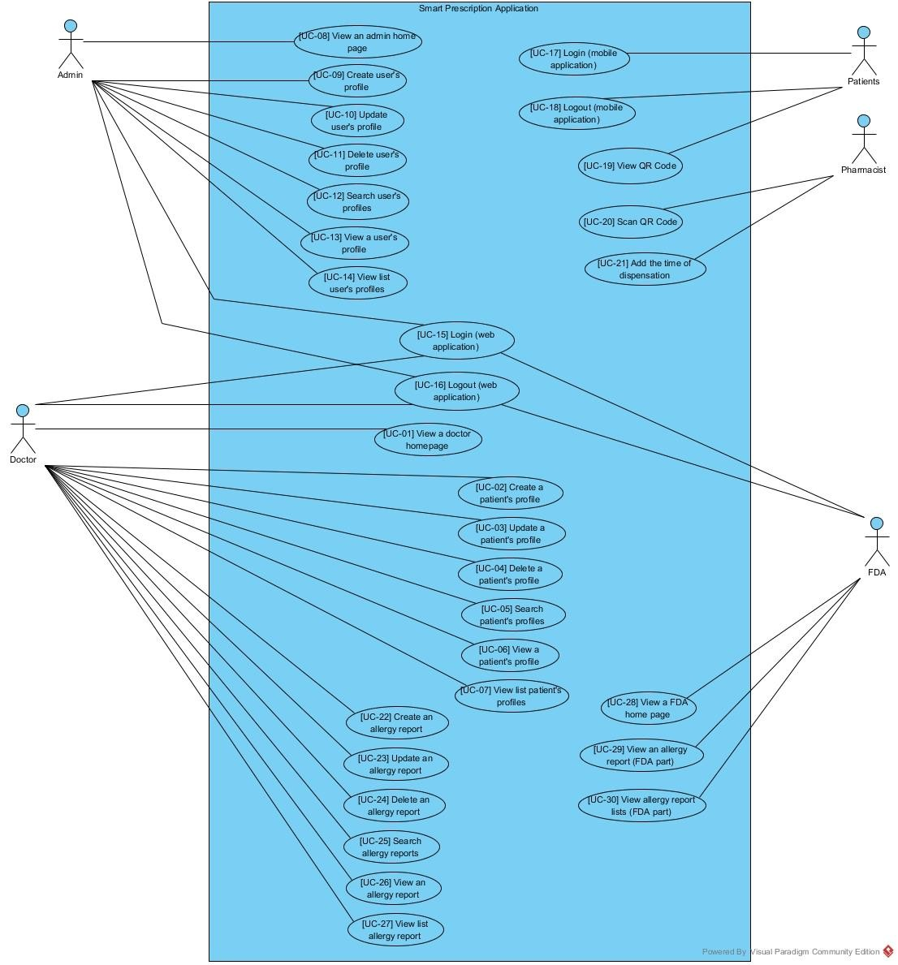

*Figure-1: Overall system diagram*

|  |  |  |  |  |  |
| --- | --- | --- | --- | --- | --- |
| **Document Name** | SMART-PRESCRIPTION-  APPLICATION- [SRS_V3.0] | **Owner** | Natthakan Kaeokanpai,  Phithiwat Sitthitun | **Page** | 20 |
| **Document Type** | Software Requirement  Specification | **Release**  **Date** | August 26th, 2016 | **Print Date** | December 9th, 2016 |

**4.1.2 Use Case Diagram (Prescription System)**

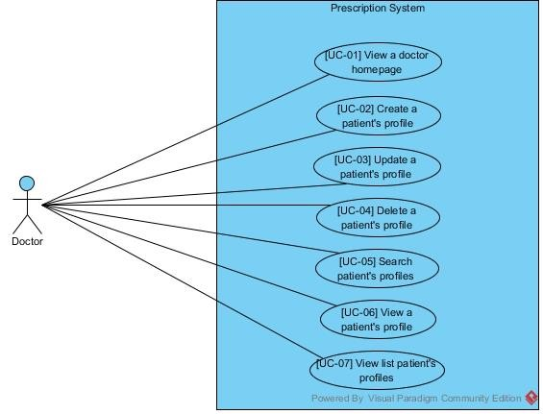

*Figure-2: Prescription system diagram*

|  |  |  |  |  |  |
| --- | --- | --- | --- | --- | --- |
| **Document Name** | SMART-PRESCRIPTION-  APPLICATION- [SRS_V3.0] | **Owner** | Natthakan Kaeokanpai,  Phithiwat Sitthitun | **Page** | 21 |
| **Document Type** | Software Requirement  Specification | **Release**  **Date** | August 26th, 2016 | **Print Date** | December 9th, 2016 |

**4.1.3 Use Case Diagram (Account Management System)**

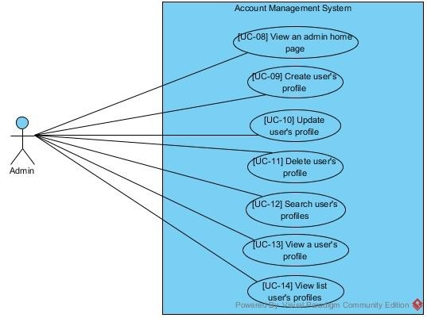

*Figure-3: Account management system diagram*

**4.1.4 Use Case Diagram (Authentication System)**

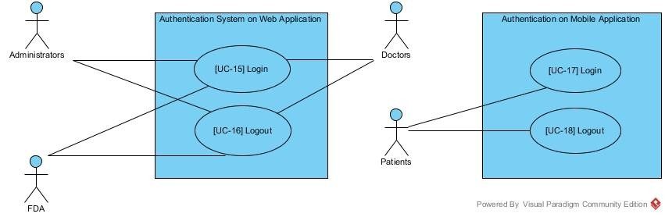

*Figure-4: Authentication system diagram*

|  |  |  |  |  |  |
| --- | --- | --- | --- | --- | --- |
| **Document Name** | SMART-PRESCRIPTION-  APPLICATION- [SRS_V3.0] | **Owner** | Natthakan Kaeokanpai,  Phithiwat Sitthitun | **Page** | 22 |
| **Document Type** | Software Requirement  Specification | **Release**  **Date** | August 26th, 2016 | **Print Date** | December 9th, 2016 |

**4.1.5 Use Case Diagram (Verification System)**

*Figure-5: Verification system diagram*

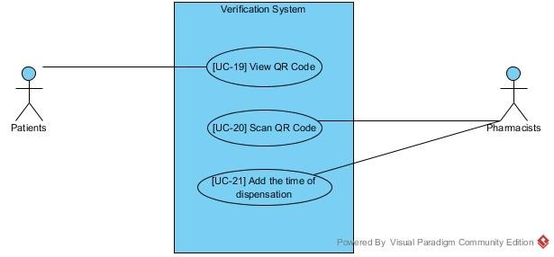

**4.1.6 Use Case Diagram (Allergy Report System)**

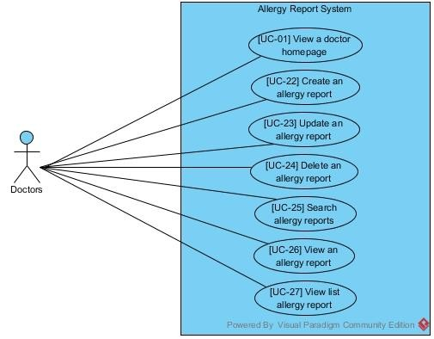

*Figure-6: Allergy report system diagram*

|  |  |  |  |  |  |
| --- | --- | --- | --- | --- | --- |
| **Document Name** | SMART-PRESCRIPTION-  APPLICATION- [SRS_V3.0] | **Owner** | Natthakan Kaeokanpai,  Phithiwat Sitthitun | **Page** | 23 |
| **Document Type** | Software Requirement  Specification | **Release**  **Date** | August 26th, 2016 | **Print Date** | December 9th, 2016 |

**4.1.7 Use Case Diagram (Summary Allergy Report System)**

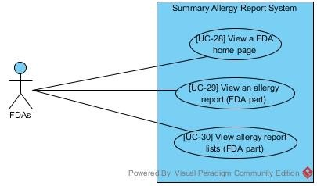

*Figure-7: Summary allergy report diagram*

|  |  |  |  |  |  |
| --- | --- | --- | --- | --- | --- |
| **Document Name** | SMART-PRESCRIPTION-  APPLICATION- [SRS_V3.0] | **Owner** | Natthakan Kaeokanpai,  Phithiwat Sitthitun | **Page** | 24 |
| **Document Type** | Software Requirement  Specification | **Release**  **Date** | August 26th, 2016 | **Print Date** | December 9th, 2016 |

**4.2 Use Case Description**

**4.2.1 Feature#1: Prescription system**

UC-01: Doctor can view a doctor home page on the web application.

|  |  |  |  |  |  |  |
| --- | --- | --- | --- | --- | --- | --- |
| **Use Case ID** | **UC-01** | | | | | |
| Use Case Name: | Doctor can view a doctor home page on the web application. | | | | | |
| Actor: | Doctors | | | | | |
| Description: | Doctors can view a doctor home page on the web application after login  successful. | | | | | |
| Trigger: |  | Doctor log in to the web application by using the doctor's side. | | | |  |
| Pre-conditions: | 1.  2. | | Administration already created the doctor profile. | |  | |
| Doctors | already login to the web application. | | |
| Post-condition: | Doctor can view the information of doctor’s profile on home page. | | | | | |
| Normal Flows: | 1. System provide the information of doctor’s profile on the home  page which include position, name, surname and username. | | | | | |

**Activity Diagram :( AD-01):**

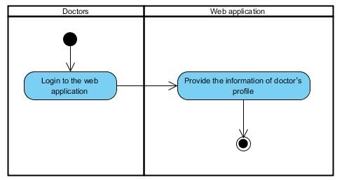

*Figure-8: Activity Diagram AD-01*

|  |  |  |  |  |  |
| --- | --- | --- | --- | --- | --- |
| **Document Name** | SMART-PRESCRIPTION-  APPLICATION- [SRS_V3.0] | **Owner** | Natthakan Kaeokanpai,  Phithiwat Sitthitun | **Page** | 25 |
| **Document Type** | Software Requirement  Specification | **Release**  **Date** | August 26th, 2016 | **Print Date** | December 9th, 2016 |

UC-02: Doctors can create a patient’s profile on the web application by inputting personal id, name, surname, prescription and username.

|  |  |  |  |  |  |
| --- | --- | --- | --- | --- | --- |
| **Use Case ID** | | **UC-02** | | | |
| Use Case Name: | | Doctors can create a patient’s profile on the web application by  inputting personal id, name, surname, prescription and username. | | | |
| Actor: | | Doctors | | | |
| Description: | | Doctors create a patient’s profile on the web application by inputting  personal id, name, surname, prescription and username. | | | |
| Trigger: | | Doctors select ‘Create’ button. | | | |
| Pre-conditions: | |  | Doctor log in to the web application by using the doctor's side. | |  |
| Post-condition: | | System displays the patient’s profile on the list of patient’s profile. | | | |
| **Use case input** | | | | | |
| **Input** | **Type** | **Constraints** | | **Example of information** | |
| personal ID | Int | Number 13 digits | | 1600100485726 | |
| name | String | Alphabet 30 digits | | Natthakan | |
| surname | String | Alphabet 30 digits | | Kaeokanpai | |
| prescription | String | String of Alphabet or number or symbol  300 digits | | Paracetamol 5 mg. | |
| username | String | Alphabet or number 20 digits | | Up2man | |
| Normal Flows: | | 1. Doctors input the information to the patient’s profile form which includes personal id, name, surname, prescription and username.  2. Doctors select ‘Create’ button.  3. System verifies the patient create form.  4. System generates a password to the patient’s profile.  5. System stores name of doctor and create date time to the database.  6. System creates the patient’s profile to the database.  7. System displays the patient’s profile on the screen. | | | |
| Alternative Flows: | | 3(A).  1. If doctors did not input the personal id field.  2. System displays error message “Personal ID cannot be blank”.  3. System works on the 7th step of normal flows.  3(B).  1. If doctors input the personal id of the patient’s profile that  already exist in the database.  2. System displays error message “Personal ID has already been exist”.  3. System works on the 7th step of normal flows.  3(C).  1. If doctors input the personal id that not follow by the constraints on the table.  2. System displays error message “Personal ID is invalid”.  3. System works on the 7th step of normal flows.  3(D).  1. If doctors did not input the name field.  2. System displays error message “Name cannot be blank”.  3. System works on the 7th step of normal flows.  3(E).  1. If doctors did not input the surname field.  2. System displays error message “Surname cannot be blank”. | | | |

|  |  |  |  |  |  |
| --- | --- | --- | --- | --- | --- |
| **Document Name** | SMART-PRESCRIPTION-  APPLICATION- [SRS_V3.0] | **Owner** | Natthakan Kaeokanpai,  Phithiwat Sitthitun | **Page** | 26 |
| **Document Type** | Software Requirement  Specification | **Release**  **Date** | August 26th, 2016 | **Print Date** | December 9th, 2016 |

3. System works on the 7th step of normal flows.

3(F).

1. If doctors did not input the prescription field.

2. System displays error message “Prescription cannot be blank”.

3. System works on the 7th step of normal flows.

3(G).

1. If doctors did not input the username d field.

2. System displays error message “Username cannot be blank”.

3. System works on the 7th step of normal flows.

3(H).

1. If doctors input the username of the patient’s profile that already exist in the database.

2. System displays error message “Username has already been taken. Please change”.

3. System works on the 7th step of normal flows.

3(I).

1. If doctors input the name not follow by the constraints on the table.

2. System displays error message “Name is invalid”.

3. System works on the 7th step of normal flows.

3(J).

1. If doctors input the surname not follow by the constraints on the table.

2. System displays error message “Surname is invalid”.

3. System works on the 7th step of normal flows.

|  |  |  |  |  |  |
| --- | --- | --- | --- | --- | --- |
| **Document Name** | SMART-PRESCRIPTION-  APPLICATION- [SRS_V3.0] | **Owner** | Natthakan Kaeokanpai,  Phithiwat Sitthitun | **Page** | 27 |
| **Document Type** | Software Requirement  Specification | **Release**  **Date** | August 26th, 2016 | **Print Date** | December 9th, 2016 |

**Activity Diagram :( AD-02):**

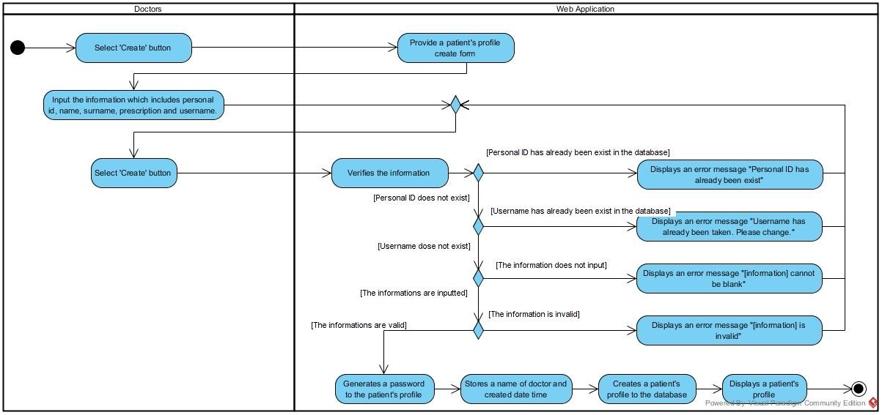

*Figure-9: Activity Diagram AD-2*

|  |  |  |  |  |  |
| --- | --- | --- | --- | --- | --- |
| **Document Name** | SMART-PRESCRIPTION-  APPLICATION- [SRS_V3.0] | **Owner** | Natthakan Kaeokanpai,  Phithiwat Sitthitun | **Page** | 28 |
| **Document Type** | Software Requirement  Specification | **Release**  **Date** | August 26th, 2016 | **Print Date** | December 9th, 2016 |

UC-03: Doctors can update a patient’s profile on the web application by input the information on the

patient’s profile form.

|  |  |  |  |  |
| --- | --- | --- | --- | --- |
| **Use Case ID** | | | **UC-03** | |
| Use Case Name: | | | Doctors can update a patient’s profile on the web application by  input the information on the patient’s profile form. | |
| Actor: | | | Doctors | |
| Description: | | | Doctors update a patient’s profile on the web application by input  the information on the patient’s profile form. | |
| Trigger: | | | Doctors select ‘update’ button on the options column of table. | |
| Pre-conditions: | | | 1. Doctors have to create a patient’s profile before updating.  2. Doctors access to manage patients page. | |
| Post-condition: | | | System displays the patient’s profile on the list of patient’s profile. | |
| **Use case input** | | | | |
| **Input** | **Type** | **Constraints** | | **Example of information** |
| personal ID | Int | Number 13 digits | | 1600100485726 |
| Name | String | Alphabet 30 digits | | Natthakan |
| Surname | String | Alphabet 30 digits | | Kaeokanpai |
| prescription | String | String of Alphabet or number or symbol  300 digits | | Parasetamol 5 mg. |
| username | String | Alphabet or number 20 digits | | Up2man |
| Normal Flows: | | | 1. Doctors input the information of patient on the patient’s  profile form.  2. Doctors select ‘save’ button.  3. System verifies the patient update form.  4. System stores name of doctor and update date time to the database.  5. System updates the patient’s profile to the database.  6. System displays the patient’s profile on the screen. | |
| Alternative Flows: | | | 3(A).  1. If doctors did not input the personal id field.  2. System displays error message “Personal ID cannot be blank”.  3. System works on the 6th step of normal flows.  3(B).  1. If doctors input the personal id of the patient’s profile that  already exist in the database.  2. System displays error message “Personal ID has already been exist”.  3. System works on the 6th step of normal flows.  3(C).  1. If doctors input the personal id that not follow by the constraints on the table.  2. System displays error message “Personal ID is invalid”.  3. System works on the 6th step of normal flows.  3(D).  1. If doctors did not input the name field.  2. System displays error message “Name cannot be blank”.  3. System works on the 6th step of normal flows.  3(E).  1. If doctors did not input the surname field.  2. System displays error message “Surname cannot be blank”.  3. System works on the 6th step of normal flows.  3(F). | |

|  |  |  |  |  |  |
| --- | --- | --- | --- | --- | --- |
| **Document Name** | SMART-PRESCRIPTION-  APPLICATION- [SRS_V3.0] | **Owner** | Natthakan Kaeokanpai,  Phithiwat Sitthitun | **Page** | 29 |
| **Document Type** | Software Requirement  Specification | **Release**  **Date** | August 26th, 2016 | **Print Date** | December 9th, 2016 |

1. If doctors did not input the prescription field.

2. System displays error message “Prescription cannot be blank”.

3. System works on the 6th step of normal flows.

3(G).

1. If doctors did not input the username d field.

2. System displays error message “Username cannot be blank”.

3. System works on the 6th step of normal flows.

3(H).

1. If doctors input the username of the patient’s profile that already exist in the database.

2. System displays error message “Username has already been taken. Please change”.

3. System works on the 6th step of normal flows.

3(I).

1. If doctors input the name not follow by the constraints on the table.

2. System displays error message “Name is invalid”.

3. System works on the 6th step of normal flows.

3(J).

1. If doctors input the surname not follow by the constraints on the table.

2. System displays error message “Surname is invalid”.

3. System works on the 6th step of normal flows.

|  |  |  |  |  |  |
| --- | --- | --- | --- | --- | --- |
| **Document Name** | SMART-PRESCRIPTION-  APPLICATION- [SRS_V3.0] | **Owner** | Natthakan Kaeokanpai,  Phithiwat Sitthitun | **Page** | 30 |
| **Document Type** | Software Requirement  Specification | **Release**  **Date** | August 26th, 2016 | **Print Date** | December 9th, 2016 |

**Activity Diagram:(AD-03):**

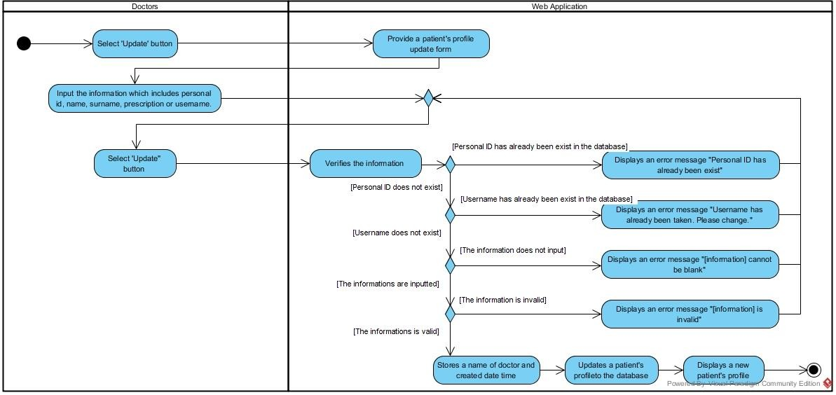

*Figure-10: Activity Diagram AD-3*

|  |  |  |  |  |  |
| --- | --- | --- | --- | --- | --- |
| **Document Name** | SMART-PRESCRIPTION-  APPLICATION- [SRS_V3.0] | **Owner** | Natthakan Kaeokanpai,  Phithiwat Sitthitun | **Page** | 31 |
| **Document Type** | Software Requirement  Specification | **Release**  **Date** | August 26th, 2016 | **Print Date** | December 9th, 2016 |

UC-4: Doctors can delete a patient’s profile on the web application.

|  |  |  |  |
| --- | --- | --- | --- |
| **Use Case ID** | **UC-04** | | |
| Use Case Name: | Doctors can delete a patient’s profile on the web application. | | |
| Actor: | Doctors | | |
| Description: | Doctors delete a patient’s profile from the database. | | |
| Trigger: | Doctor selects ‘delete’ button on the options column of table. | | |
| Pre-conditions: | 1. | Doctors need to log in by using the doctor's side. |  |
| 2. Doctors access to manage patients page | | |
| Post-condition: | System deletes a patient’s profile from the database. | | |
| Normal Flows: | 1. System displays an alert message “Are you sure you want to  delete this item?” with ‘Ok’ button and ‘Cancel’ button.  2. Doctors select ‘Ok’ button.  3. System deletes the patient’s profile from the database.  4. System displays a list of patient's profile. | | |
| Alternative Flows: | 4(A).  1. Doctors select ‘Cancel’ button.  2. System works on the 4th step of normal flows. | | |
| Exceptions: | N/A | | |

**Activity Diagram :( AD-04)**

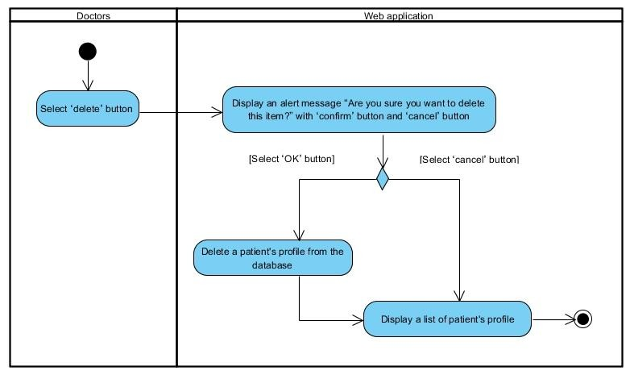

*Figure-11: Activity Diagram AD-4*

|  |  |  |  |  |  |
| --- | --- | --- | --- | --- | --- |
| **Document Name** | SMART-PRESCRIPTION-  APPLICATION- [SRS_V3.0] | **Owner** | Natthakan Kaeokanpai,  Phithiwat Sitthitun | **Page** | 32 |
| **Document Type** | Software Requirement  Specification | **Release**  **Date** | August 26th, 2016 | **Print Date** | December 9th, 2016 |

UC-05: Doctors can search a patient’s profile on the web application by using personal id, name, and surname.

|  |  |  |  |  |  |
| --- | --- | --- | --- | --- | --- |
| **Use Case ID** | | **UC-05** | | | |
| Use Case Name: | | Doctors can search a patient’s profile on the web application by  using personal id, name, or surname. | | | |
| Actor: | | Doctors | | | |
| Description: | | Doctors search a patient’s profile by input by using personal id,  name, or surname.to the search field. | | | |
| Trigger: | | Doctors select ‘Search’ button. | | | |
| Pre-conditions: | | 1. | Doctors need to log in by using doctor's side. | |  |
| 2. Doctors access to manage patients page | | | |
| Post-condition: | | System displays a patient’s profile that match with a keyword  search from the database. | | | |
| **Use case input** | | | | | |
| **Input** | **Type** | **Constraint** | | **Example of information** | |
| Keyword | String | String of alphabet | | Natthakan | |
| Normal Flows: | | 1. Doctors input a keyword search (personal id, name, or surname) to the search field.  2. Doctors select ‘search’ button.  3. System verifies a keyword search.  4. System retrieves a patient’s profile from the database that match with a keyword search.  5. System displays a patient’s profile. | | | |
| Alternative Flows: | | 3(A).  1. System displays a message “No results found” if there are no data that match with a keyword search in the database. | | | |

**Activity Diagram:(AD-05):**

*Figure-12: Activity Diagram AD-5*

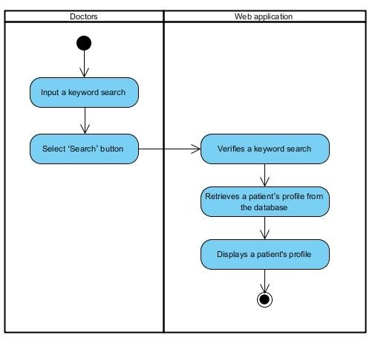

|  |  |  |  |  |  |
| --- | --- | --- | --- | --- | --- |
| **Document Name** | SMART-PRESCRIPTION-  APPLICATION- [SRS_V3.0] | **Owner** | Natthakan Kaeokanpai,  Phithiwat Sitthitun | **Page** | 33 |
| **Document Type** | Software Requirement  Specification | **Release**  **Date** | August 26th, 2016 | **Print Date** | December 9th, 2016 |

UC-06: Doctors can view a patient’s profile on the web application.

|  |  |  |  |  |  |
| --- | --- | --- | --- | --- | --- |
| **Use Case ID** | **UC-06** | | | | |
| Use Case Name: | Doctors can view a patient’s profile on the web application. | | | | |
| Actor: | Doctors | | | | |
| Description: | Doctors view a patient’s profile by select the patient’s profile for  view the information of patient on the web application. | | | | |
| Trigger: | Doctors select ‘View’ button on the options column of table. | | | | |
| Pre-conditions: | 1. Doctors | need to log in by using the | doctor | 's side. |  |
| 2. Doctors access to manage patients page | | | | |
| Post-condition: | Doctors view a patient’s profile. | | | | |
| Normal Flows: | 1. Doctors select view button.  2. System retrieves a patient’s profile from the database.  3. System displays a patient’s profile. | | | | |
| Alternative Flows: | N/A | | | | |

**Activity Diagram:(AD-06):**

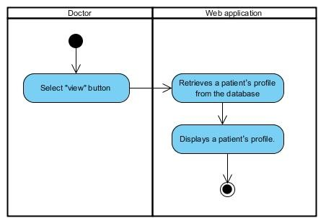

*Figure-13: Activity Diagram AD-*6

|  |  |  |  |  |  |
| --- | --- | --- | --- | --- | --- |
| **Document Name** | SMART-PRESCRIPTION-  APPLICATION- [SRS_V3.0] | **Owner** | Natthakan Kaeokanpai,  Phithiwat Sitthitun | **Page** | 34 |
| **Document Type** | Software Requirement  Specification | **Release**  **Date** | August 26th, 2016 | **Print Date** | December 9th, 2016 |

UC-07: Doctors can view a list of patient’s profile on the web application.

|  |  |  |  |
| --- | --- | --- | --- |
| **Use Case ID** | **UC-07** | | |
| Use Case Name: | Doctors can view a list of patient’s profile on the web application. | | |
| Actor: | Doctors | | |
| Description: | Doctors view a list of patient’s profile. | | |
| Trigger: | Doctors select ‘Manage Patients’ button on the patient options menu  box. | | |
| Pre-conditions: |  | Doctors need to log in by using the doctor's side. |  |
| Post-condition: | Doctors view a list of patient’s profile. | | |
| Normal Flows: | 1. System provides a list of patient’s profile. | | |
| Exceptions: | System does not display a list of patient’s profile if there is no a  patient’s profile in the database. | | |

**Activity Diagram:(AD-07):**

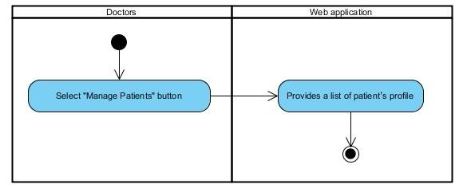

*Figure-14: Activity Diagram AD-*7

|  |  |  |  |  |  |
| --- | --- | --- | --- | --- | --- |
| **Document Name** | SMART-PRESCRIPTION-  APPLICATION- [SRS_V3.0] | **Owner** | Natthakan Kaeokanpai,  Phithiwat Sitthitun | **Page** | 35 |
| **Document Type** | Software Requirement  Specification | **Release**  **Date** | August 26th, 2016 | **Print Date** | December 9th, 2016 |

**4.2.2 Feature#2: Account management system**

UC-08 Administration can view an administration home page on the web application.

**Use Case ID UC-08**

Use Case Name: Administrator can view an administration home page on the web application.

Actor: Administrator

Description: Administrator can view an administration home page on the web application after login successful.

Trigger: Administrator log in to the web application by using the administration's side.

Pre-conditions: 1. Administrator already has the administrator profile.

2. Administrator already login to the web application.

Post-condition: Administrator can view the information of administrator’s profile on

home page.

Normal Flows: 1. Systems provide the information of Administrator’s profile on

the home page.

**Activity Diagram :( AD-08):**

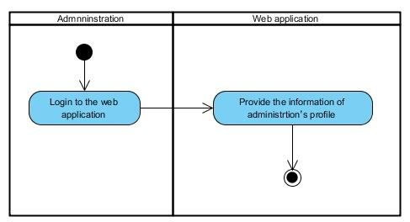

*Figure-15: Activity Diagram AD-8*

|  |  |  |  |  |  |
| --- | --- | --- | --- | --- | --- |
| **Document Name** | SMART-PRESCRIPTION-  APPLICATION- [SRS_V3.0] | **Owner** | Natthakan Kaeokanpai,  Phithiwat Sitthitun | **Page** | 36 |
| **Document Type** | Software Requirement  Specification | **Release**  **Date** | August 26th, 2016 | **Print Date** | December 9th, 2016 |

UC-09: Administrators can create a user’s profile on the web application by inputting name, surname, password, confirm-password and position.

|  |  |  |  |  |  |  |  |
| --- | --- | --- | --- | --- | --- | --- | --- |
| Use Case ID | | UC-09 | | | | | |
| Use Case Name: | | Administrator can create a user’s profile on the web application by  inputting name, surname, password, confirm-password and position. | | | | | |
| Actor: | | Administrator | | | | | |
| Description: | | Administrator creates a user’s profile to the database by inputting  name, surname, password, confirm-password and position. | | | | | |
| Trigger: | | Administrator select ‘Create User’ button. | | | | | |
| Pre-conditions: | | Administrator | log in by using the | administration | | ’s side. |  |
| Post-condition: | | System displays a user’s profile. | | | | | |
| **Use case input** | | | | | | | |
| **Input** | **Type** | **Constraints** | | | **Example** | | |
| position | Int | Number 1 digit | | | 2 | | |
| name | String | Alphabetic 30 digits | | | Natthakan | | |
| surname | String | Alphabetic 30 digits | | | Kaeokanpai | | |
| username | String | Alphabetic or number 20 digits | | | Up2man | | |
| password | String | Alphabetic or number 20 digits | | | 7885 | | |
| password2 | String | Alphabetic or number 20 digits | | | 7885 | | |
| Normal Flows: | | 1. Administrators input the information of user’s profile.  2. Administrators select ‘create’ button.  3. System verifies a user create form.  4. System creates a user’s profile to database.  5. System displays a user’s profile. | | | | | |
| Alternative Flows: | | 3(A).  1. If administrators did not input the name field.  2. System displays error message “Name cannot be blank”.  3. System works on the 5th step of normal flows.  3(B).  1. If administrators did not input the surname field.  2. System displays error message “Surname cannot be blank”.  3. System works on the 5th step of normal flows.  3(C).  1. If administrators did not input the username field.  2. System displays error message “Username cannot be blank”.  3. System works on the 5th step of normal flows.  3(D).  1. If administrators input the username of the patient’s profile that already exist in the database.  2. System displays error message “Username has already been  taken. Please change”.  3. System works on the 5th step of normal flows.  3(E).  1. If administrators did not input the password field.  2. System displays error message “Password cannot be blank”.  3. System works on the 5th step of normal flows.  3(F).  1. If administrators did not input the confirm-password field.  2. System displays error message “Con-firm password cannot  be blank”.  3. System works on the 5th step of normal flows. | | | | | |

|  |  |  |  |  |  |
| --- | --- | --- | --- | --- | --- |
| **Document Name** | SMART-PRESCRIPTION-  APPLICATION- [SRS_V3.0] | **Owner** | Natthakan Kaeokanpai,  Phithiwat Sitthitun | **Page** | 37 |
| **Document Type** | Software Requirement  Specification | **Release**  **Date** | August 26th, 2016 | **Print Date** | December 9th, 2016 |

3(G).

1. If administrators did not input the confirm-password field.

2. System displays error message “Password and Con-firm password do not match”.

3. System works on the 5th step of normal flows.

3(H).

1. If administrators input the name not follow by the constraints on the table.

2. System displays error message “Name is invalid”.

3. System works on the 5th step of normal flows.

3(I).

1. If administrators input the surname not follow by the constraints on the table.

2. System displays error message “Surname is invalid”.

3. System works on the 5th step of normal flows.

3(J).

1. If administrators did not input the position field.

2. System displays error message “Position cannot be blank”.

3. System works on the 5th step of normal flows.

|  |  |  |  |  |  |
| --- | --- | --- | --- | --- | --- |
| **Document Name** | SMART-PRESCRIPTION-  APPLICATION- [SRS_V3.0] | **Owner** | Natthakan Kaeokanpai,  Phithiwat Sitthitun | **Page** | 38 |
| **Document Type** | Software Requirement  Specification | **Release**  **Date** | August 26th, 2016 | **Print Date** | December 9th, 2016 |

**Activity Diagram:(AD-09):**

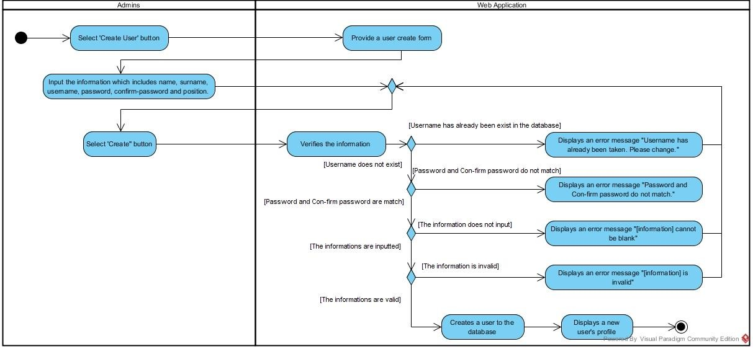

*Figure-16: Activity Diagram AD-*9

|  |  |  |  |  |  |
| --- | --- | --- | --- | --- | --- |
| **Document Name** | SMART-PRESCRIPTION-  APPLICATION- [SRS_V3.0] | **Owner** | Natthakan Kaeokanpai,  Phithiwat Sitthitun | **Page** | 39 |
| **Document Type** | Software Requirement  Specification | **Release**  **Date** | August 26th, 2016 | **Print Date** | December 9th, 2016 |

UC-10: Administrators can update a user’s profile on the web application by inputting name, surname, password, confirm-password or position.

|  |  |  |  |  |  |  |  |
| --- | --- | --- | --- | --- | --- | --- | --- |
| **Use Case ID** | | UC-10 | | | | | |
| Use Case Name: | | Administrators can update a user’s profile on the web application by  inputting name, surname, password, confirm-password or position. | | | | | |
| Actor: | | Administrators | | | | | |
| Description: | | Administrators update a user’s profile to the database by inputting  name, surname, password, confirm-password and position. | | | | | |
| Trigger: | | Administrators select ‘Update’ button on the options column of  table. | | | | | |
| Pre-conditions: | | 1. Administrators | log in by using the | | administration | ’s side. |  |
| 2. Administrators access to manage user page. | | | | | |
| Post-condition: | | Administrations view a user’s profile. | | | | | |
| **Use case input** | | | | | | | |
| **Input** | **Type** | **Constraints** | | **Example** | | | |
| position | Int | Number 1 digit | | 2 | | | |
| name | String | Alphabetic 30 digits | | Natthakan | | | |
| surname | String | Alphabetic 30 digits | | Kaeokanpai | | | |
| username | String | Alphabetic or number 20 digits | | Up2man | | | |
| password | String | Alphabetic or number 20 digits | | 7885 | | | |
| password2 | String | Alphabetic or number 20 digits | | 7885 | | | |
| Normal Flows: | | 1. Administrations input the information of user’s profile.  2. Administrations select ‘Update’ button.  3. System verifies a user update form.  4. System saves a user’s profile to database.  5. System displays a user’s profile. | | | | | |
| Alternative Flows: | | 3(A).  1. If administrators did not input the name field.  2. System displays error message “Name cannot be blank”.  3. System works on the 5th step of normal flows.  3(B).  1. If administrators did not input the surname field.  2. System displays error message “Surname cannot be blank”.  3. System works on the 5th step of normal flows.  3(C).  1. If administrators did not input the username field.  2. System displays error message “Username cannot be blank”.  3. System works on the 5th step of normal flows.  3(D).  1. If administrators input the username of the patient’s profile that already exist in the database.  2. System displays error message “Username has already been  taken. Please change”.  3. System works on the 5th step of normal flows.  3(E).  1. If administrators did not input the password field.  2. System displays error message “Password cannot be blank”.  3. System works on the 5th step of normal flows.  3(F).  1. If administrators did not input the confirm-password field.  2. System displays error message “Con-firm password cannot  be blank”.  3. System works on the 5th step of normal flows. | | | | | |

|  |  |  |  |  |  |
| --- | --- | --- | --- | --- | --- |
| **Document Name** | SMART-PRESCRIPTION-  APPLICATION- [SRS_V3.0] | **Owner** | Natthakan Kaeokanpai,  Phithiwat Sitthitun | **Page** | 40 |
| **Document Type** | Software Requirement  Specification | **Release**  **Date** | August 26th, 2016 | **Print Date** | December 9th, 2016 |

|  |  |
| --- | --- |
|  | 3(G).  1. If administrators did not input the confirm-password field.  2. System displays error message “Password and Con-firm password do not match”.  3. System works on the 5th step of normal flows.  3(H).  1. If administrators input the name not follow by the constraints on the table.  2. System displays error message “Name is invalid”.  3. System works on the 5th step of normal flows.  3(I).  1. If administrators input the surname not follow by the constraints on the table.  2. System displays error message “Surname is invalid”.  3. System works on the 5th step of normal flows.  3(J).  1. If administrators did not input the position field.  2. System displays error message “Position cannot be blank”.  3. System works on the 5th step of normal flows. |
| Exceptions: | N/A |

|  |  |  |  |  |  |
| --- | --- | --- | --- | --- | --- |
| **Document Name** | SMART-PRESCRIPTION-  APPLICATION- [SRS_V3.0] | **Owner** | Natthakan Kaeokanpai,  Phithiwat Sitthitun | **Page** | 41 |
| **Document Type** | Software Requirement  Specification | **Release**  **Date** | August 26th, 2016 | **Print Date** | December 9th, 2016 |

**Activity Diagram:(AD-10):**

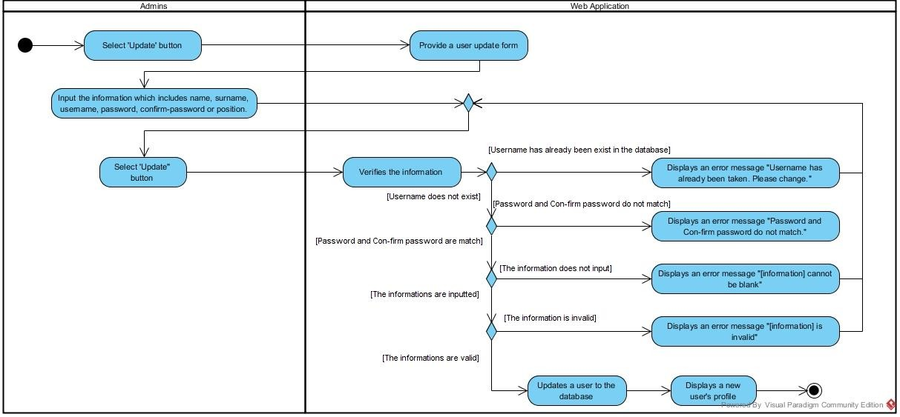

*Figure-17: Activity Diagram AD-10*

|  |  |  |  |  |  |
| --- | --- | --- | --- | --- | --- |
| **Document Name** | SMART-PRESCRIPTION-  APPLICATION- [SRS_V3.0] | **Owner** | Natthakan Kaeokanpai,  Phithiwat Sitthitun | **Page** | 42 |
| **Document Type** | Software Requirement  Specification | **Release**  **Date** | August 26th, 2016 | **Print Date** | December 9th, 2016 |

UC-11: Administrators can delete user’s profiles on the web application.

|  |  |  |  |  |  |
| --- | --- | --- | --- | --- | --- |
| **Use Case ID** | UC-11 | | | | |
| Use Case Name: | Administrators can delete a user’s profile on the web application. | | | | |
| Actor: | Administrators | | | | |
| Description: | Administrators delete a user’s profile from list of user’s profile. | | | | |
| Trigger: | Administrators select “Delete” button on the options column of  table. | | | | |
| Pre-conditions: | 1. Administrator | s need to log in by using | administration | ’s side. |  |
| 2. Administrators access to manage user page. | | | | |
| Post-condition: | System deletes a user’s profile from the database. | | | | |
| Normal Flows: | 1. Administrations selects ‘delete’ button.  2. System displays an alert message “Are you sure you want to delete this item?” with ‘Ok’ button and ‘Cancel’ button.  3. Administrations select ‘Ok’ button.  4. System deletes the user’s profile from the database. | | | | |
| Alternative Flows: | 4(A).  1. Administrators select ‘Cancel’ button.  2. System works on the 1st step of normal flows. | | | | |
| Exceptions: | N/A | | | | |

**Activity Diagram :(AD-11)**

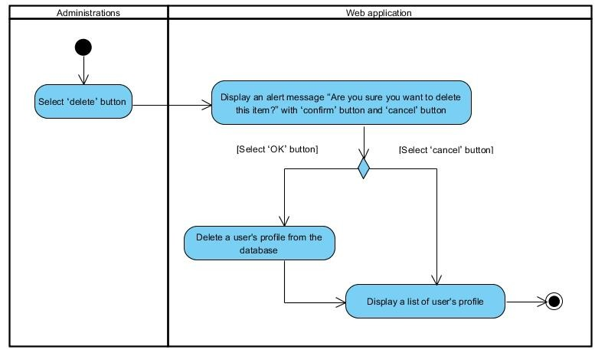

*Figure-18: Activity Diagram AD-11*

|  |  |  |  |  |  |
| --- | --- | --- | --- | --- | --- |
| **Document Name** | SMART-PRESCRIPTION-  APPLICATION- [SRS_V3.0] | **Owner** | Natthakan Kaeokanpai,  Phithiwat Sitthitun | **Page** | 43 |
| **Document Type** | Software Requirement  Specification | **Release**  **Date** | August 26th, 2016 | **Print Date** | December 9th, 2016 |

UC-12: Administrators can search a user’s profile on the web application by using name, surname, or username.

**Use Case ID** UC-12

Use Case Name: Administrators can search a user’s profile on the web application by using name, surname, or username.

Actor: Administrators

Description: Administrators search a user’s profile by using name, surname, or username.

Trigger: Administrators select ‘Search’ button.

Pre-conditions: 1. Administrators log in by using administration's side.

2. Administrators access to manage user page.

Post-condition: System displays a user’s profile.

**Use case input**

|  |  |  |  |
| --- | --- | --- | --- |
| **Input** | **Type** | **Constraints** | **Example of information** |
| Keyword of searching | String | String of alphabet | Prayuth |

Normal Flows: 1. Administrators input a name, surname, or username of user

to the search bars.

2. Administrators select ‘search’ button.

3. System validates a keyword search.

4. System retrieves a user’s profile from the database that match with a keyword search.

5. System displays a user’s profile.

Alternative Flows: 3(A).

3. System displays a message “No results found” if there are no data that match with a keyword search in the database.

Exceptions: N/A

**Activity Diagram:(AD-12):**

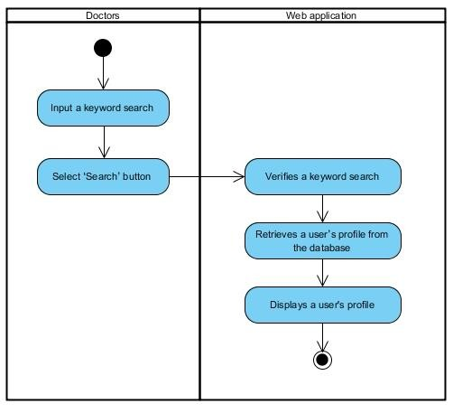

*Figure-19: Activity Diagram AD-12*

|  |  |  |  |  |  |
| --- | --- | --- | --- | --- | --- |
| **Document Name** | SMART-PRESCRIPTION-  APPLICATION- [SRS_V3.0] | **Owner** | Natthakan Kaeokanpai,  Phithiwat Sitthitun | **Page** | 44 |
| **Document Type** | Software Requirement  Specification | **Release**  **Date** | August 26th, 2016 | **Print Date** | December 9th, 2016 |

UC-13: Administrators can view user’s profile on the web application.

|  |  |  |  |
| --- | --- | --- | --- |
| **Use Case ID** | UC-13 | | |
| Use Case Name: | Administrators can view user’s profiles on the web application. | | |
| Actor: | Administrators | | |
| Description: | Administrators view user’s profile on list of user’s profiles. | | |
| Trigger: | Administrators select ‘View’ button on the options column of table. | | |
| Pre-conditions: | 1. Administrators | need to log in by using the | administration’s |
| side.  2. Administrators access to manage user page. | | |
| Post-condition: | Administrators view a user’s profile. | | |
| Normal Flows: | 1. Doctors select view button.  2. System retrieves a user’s profile from the database.  3. System displays a user’s profile. | | |
| Alternative Flows: | N/A | | |

**Activity Diagram :( AD-13):**

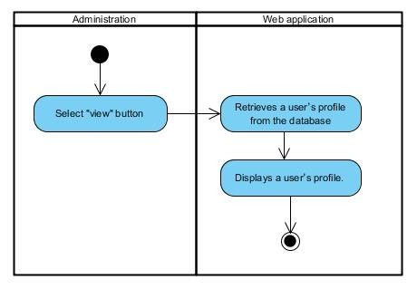

*Figure-20: Activity Diagram AD-13*

|  |  |  |  |  |  |
| --- | --- | --- | --- | --- | --- |
| **Document Name** | SMART-PRESCRIPTION-  APPLICATION- [SRS_V3.0] | **Owner** | Natthakan Kaeokanpai,  Phithiwat Sitthitun | **Page** | 45 |
| **Document Type** | Software Requirement  Specification | **Release**  **Date** | August 26th, 2016 | **Print Date** | December 9th, 2016 |

UC-14: Administrators can view a list of user’s profiles on the web application.

|  |  |  |  |  |  |
| --- | --- | --- | --- | --- | --- |
| Use Case ID | UC-14 | | | | |
| Use Case Name: | Administrators can view list of user’s profiles. | | | | |
| Actor: | Administrators | | | | |
| Description: | Administrators view a list of user’s profiles. | | | | |
| Trigger: | Administrators select ‘Manage Users’ button on the options menu  box. | | | | |
| Pre-conditions: | Administrators | need to log in by using | administration | 's side. |  |
| Post-condition: | Administrators view a list of user’s profiles. | | | | |
| Normal Flows: | 1. System retrieves all of user’s profiles from the database.  2. System displays a list of user’s profile. | | | | |
| Exceptions: | System does not display a list of user’s profile if there is no a user’s  profile in the database. | | | | |

**Activity Diagram:(AD-14):**

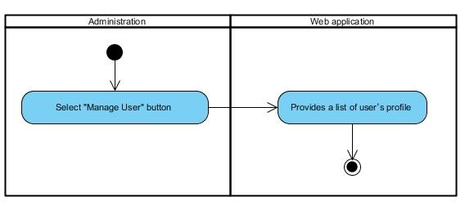

*Figure-21: Activity Diagram AD-14*

|  |  |  |  |  |  |
| --- | --- | --- | --- | --- | --- |
| **Document Name** | SMART-PRESCRIPTION-  APPLICATION- [SRS_V3.0] | **Owner** | Natthakan Kaeokanpai,  Phithiwat Sitthitun | **Page** | 46 |
| **Document Type** | Software Requirement  Specification | **Release**  **Date** | August 26th, 2016 | **Print Date** | December 9th, 2016 |

**4.2.3 Feature#3: Authentication system**

UC-15: Doctors, Administrators, and FDAs can login to the web application.

|  |  |  |  |  |
| --- | --- | --- | --- | --- |
| **Use Case ID** | | **UC-15** | | |
| Use Case Name: | | Doctors, Administrators, and FDAs can login to the web application. | | |
| Actor: | | Doctors, Administrators, or FDAs | | |
| Description: | | Users login to the web application by use the username and password. | | |
| Trigger: | | Users select ‘login’ button on the menu bars. | | |
| Pre-conditions: | | 1. Users access to the web application  2. Users already have the username and password. | | |
| Post-condition: | | System provides the home page after login completed. | | |
| **Use case input** | | | | |
| **Input** | **Type** | | **Constraints** | **Example of information** |
| Username | String | | Alphabet or number 20 digits | taksin |
| Password | String | | Alphabet or number 20 digits | 1234 |
| Normal Flows: | | 1. Users input the username and password to the login form.  2. Users select ‘login’ button on the login form.  3. System verifies the username and password.  4. System redirects the users to the home page. | | |
| Alternative Flows: | | 3(A).  1. System displays the error box message “Username is  Incorrect!” if users input the username incorrectly.  2. System works on the 4th step in normal flows.  3(B).  1. System displays the error box message “Password is Incorrect!”  if users input the password incorrectly.  2. System works on the 4th step in normal flows.  3(C).  1. System displays the error box message “Username cannot be blank.” if users do not input the username.  2. System works on the 4th step in normal flows.  3(D).  1. System displays the error box message “Password cannot be  blank “if users do not input the password.  2. System works on the 4th step in normal flows. | | |
| Exceptions: | | N/A | | |

|  |  |  |  |  |  |
| --- | --- | --- | --- | --- | --- |
| **Document Name** | SMART-PRESCRIPTION-  APPLICATION- [SRS_V3.0] | **Owner** | Natthakan Kaeokanpai,  Phithiwat Sitthitun | **Page** | 47 |
| **Document Type** | Software Requirement  Specification | **Release**  **Date** | August 26th, 2016 | **Print Date** | December 9th, 2016 |

**Activity Diagram:(AD-15):**

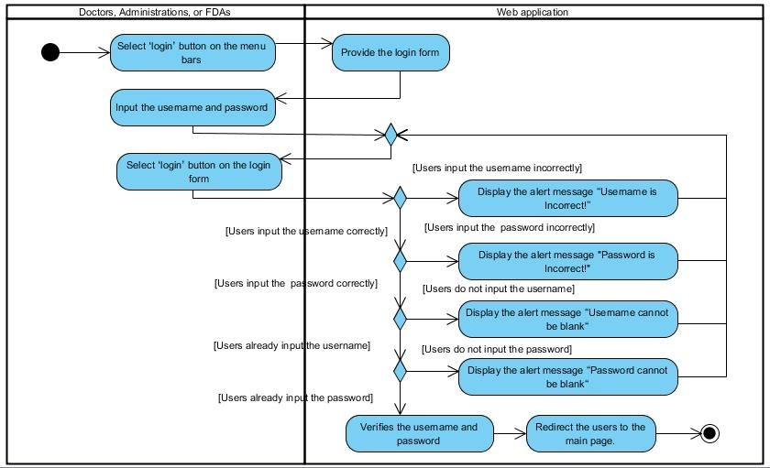

*Figure-22: Activity Diagram AD-15*

|  |  |  |  |  |  |
| --- | --- | --- | --- | --- | --- |
| **Document Name** | SMART-PRESCRIPTION-  APPLICATION- [SRS_V3.0] | **Owner** | Natthakan Kaeokanpai,  Phithiwat Sitthitun | **Page** | 48 |
| **Document Type** | Software Requirement  Specification | **Release**  **Date** | August 26th, 2016 | **Print Date** | December 9th, 2016 |

UC-16: Doctors, Administrators, and FDAs can logout from the web application.

|  |  |
| --- | --- |
| **Use Case ID** | **UC-16** |
| Use Case Name: | Doctors, Administrators, and FDAs can logout from the web  application. |
| Actor: | Doctors, Administrators, and FDAs |
| Description: | Users log out from the web application by click ‘logout’ button on  the menu bars. |
| Trigger: | Users select ‘logout’ button on the menu bar. |
| Pre-conditions: | Users have to login to the web application. |
| Post-condition: | System provides the login page to the user. |
| Normal Flows: | 1. Users select ‘logout’ button on the menu bars.  2. System redirects the users to the login page. |
| Alternative Flows: | N/A |
| Exceptions: | N/A |

**Activity Diagram:(AD-16):**

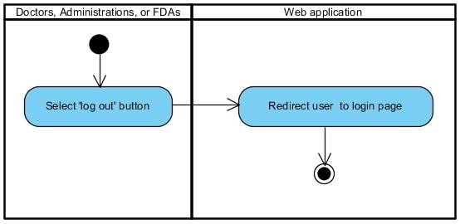

*Figure-23: Activity Diagram AD-16*

|  |  |  |  |  |  |
| --- | --- | --- | --- | --- | --- |
| **Document Name** | SMART-PRESCRIPTION-  APPLICATION- [SRS_V3.0] | **Owner** | Natthakan Kaeokanpai,  Phithiwat Sitthitun | **Page** | 49 |
| **Document Type** | Software Requirement  Specification | **Release**  **Date** | August 26th, 2016 | **Print Date** | December 9th, 2016 |

UC-17: Patients can login to the mobile application.

|  |  |
| --- | --- |
| **Use Case ID** | **UC-17** |
| Use Case Name: | Patients can login to the mobile application. |
| Actor: | Patients |
| Description: | Patients access to the mobile application. |
| Trigger: | Patients access to the mobile application. |
| Pre-conditions: | Patients already have username and password. |
| Post-condition: | System provides the main page after login completed. |
| Normal Flows: | 1. Users input the username and password to the login form.  2. Users select ‘login’ button on the login form.  3. System verifies the username and password.  4. System redirects the users to the main page. |
| Alternative Flows: | 4(A).  1. System displays the alert message “Incorrect username or password” if users input the username or password  incorrectly.  2. System works on the 4th step in normal flows.  4(B).  1. System displays the alert message “Cannot be blank “if  users do not input the username and password on the login form.  2. System works on the 4h step in normal flows. |
| Exceptions: | N/A |

|  |  |  |  |  |  |
| --- | --- | --- | --- | --- | --- |
| **Document Name** | SMART-PRESCRIPTION-  APPLICATION- [SRS_V3.0] | **Owner** | Natthakan Kaeokanpai,  Phithiwat Sitthitun | **Page** | 50 |
| **Document Type** | Software Requirement  Specification | **Release**  **Date** | August 26th, 2016 | **Print Date** | December 9th, 2016 |

**Activity Diagram:(AD-17):**

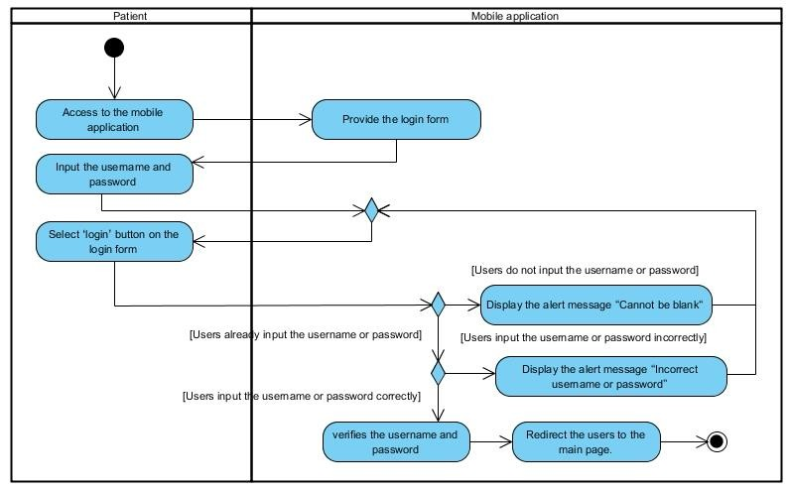

*Figure-24: Activity Diagram AD-17*

|  |  |  |  |  |  |
| --- | --- | --- | --- | --- | --- |
| **Document Name** | SMART-PRESCRIPTION-  APPLICATION- [SRS_V3.0] | **Owner** | Natthakan Kaeokanpai,  Phithiwat Sitthitun | **Page** | 51 |
| **Document Type** | Software Requirement  Specification | **Release**  **Date** | August 26th, 2016 | **Print Date** | December 9th, 2016 |

UC-18: Patients can logout from the mobile application.

|  |  |
| --- | --- |
| **Use Case ID** | **UC-18** |
| Use Case Name: | Patients can logout from the mobile application. |
| Actor: | Patients |
| Description: | Patients log out from the mobile application by click ‘logout’ button. |
| Trigger: | Patients select ‘logout’ button. |
| Pre-conditions: | Patients have to login to mobile web application. |
| Post-condition: | System exists from the mobile application. |
| Normal Flows: | 1. Patients select ‘logout’ button.  2. System redirects the user to the login page. |
| Alternative Flows: | N/A |
| Exceptions: | N/A |

**Activity Diagram:(AD-18):**

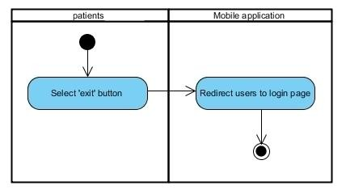

*Figure-25: Activity Diagram AD-18*

|  |  |  |  |  |  |
| --- | --- | --- | --- | --- | --- |
| **Document Name** | SMART-PRESCRIPTION-  APPLICATION- [SRS_V3.0] | **Owner** | Natthakan Kaeokanpai,  Phithiwat Sitthitun | **Page** | 52 |
| **Document Type** | Software Requirement  Specification | **Release**  **Date** | August 26th, 2016 | **Print Date** | December 9th, 2016 |

**3.2.4 Feature#4: Verify prescription system**

UC-19: Patients can view the QR code on the mobile application.

|  |  |  |  |
| --- | --- | --- | --- |
| **Use Case ID** | **UC-19** | | |
| Use Case Name: | Patients can view the QR code on the mobile application. | | |
| Actor: | Patients | | |
| Description: | Patient can view the QR code after select ‘Show QR code’ button. | | |
| Trigger: | Patient | s select ‘Show QR code’ button. |  |
| Pre-conditions: | 1. Doctors have to created patient’s profile.  2. Patients access to the mobile application. | | |
| Post-condition: | System displays the QR code to a patient on the mobile application. | | |
| Normal Flows: | 1. System generates the QR code of patient’s profiles.  2. System displays the QR code on the screen. | | |
| Alternative Flows: | N/A | | |
| Exceptions: | N/A | | |

**Activity Diagram:(AD-19):**

*Figure-26 Activity Diagram AD-19*

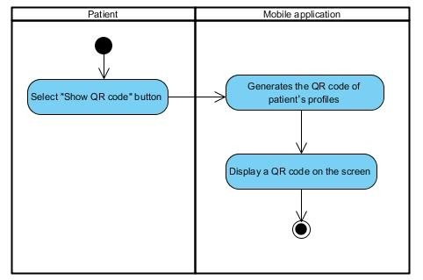

|  |  |  |  |  |  |
| --- | --- | --- | --- | --- | --- |
| **Document Name** | SMART-PRESCRIPTION-  APPLICATION- [SRS_V3.0] | **Owner** | Natthakan Kaeokanpai,  Phithiwat Sitthitun | **Page** | 53 |
| **Document Type** | Software Requirement  Specification | **Release**  **Date** | August 26th, 2016 | **Print Date** | December 9th, 2016 |

UC-20: Pharmacists can scan the QR code on the mobile application.

|  |  |  |  |  |
| --- | --- | --- | --- | --- |
| **Use Case ID** | **UC-20** | | | |
| Use Case Name: | Pharmacists can scan the QR code on the mobile application. | | | |
| Actor: | Pharmacists | | | |
| Description: | Pharmacists can scan the QR code by select ‘scan’ button and  capture the QR code with the camera of mobile phone. | | | |
| Trigger: | Pharmacists select ‘scan’ button. | | | |
| Pre-conditions: | Pharmacists | already | have the ‘scan barcode’ application. |  |
| Post-condition: | System displays the information of patient’s profile to  pharmacist on the mobile application. | | | |
| Normal Flows: | 1. Pharmacists select ‘scan’ button.  2. Systems provide scan QR code function on the mobile application.  3. Pharmacists scan the QR code.  4. System displays the information of patient’s profile on the mobile application. | | | |
| Alternative Flows: | N/A | | | |
| Exceptions: | N/A | | | |

**Activity Diagram:(AD-20):**

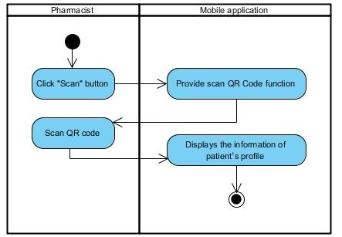

*Figure-27: Activity Diagram AD-20*

|  |  |  |  |  |  |
| --- | --- | --- | --- | --- | --- |
| **Document Name** | SMART-PRESCRIPTION-  APPLICATION- [SRS_V3.0] | **Owner** | Natthakan Kaeokanpai,  Phithiwat Sitthitun | **Page** | 54 |
| **Document Type** | Software Requirement  Specification | **Release**  **Date** | August 26th, 2016 | **Print Date** | December 9th, 2016 |

UC-21: Pharmacists can add the time of dispensation to the patient’s profile on the mobile

application.

|  |  |
| --- | --- |
| **Use Case ID** | **UC-21** |
| Use Case Name: | Pharmacists can add the time of dispensation to the patient’s  profile on the mobile application. |
| Actor: | Pharmacists |
| Description: | System record the present time and date to database after  pharmacist selects ‘confirm’ button on the mobile application. |
| Trigger: | Pharmacists select ‘confirm’ button. |
| Pre-conditions: | 1. Pharmacists access to the mobile application.  2. Pharmacists already scan the QR code successful. |
| Post-condition: | System record the present time and date to the patient’s profile. |
| Normal Flows: | 1. Systems record the present time of dispensing to the  patient’s profile.  2. Systems display message “Successful” on screen. |
| Alternative Flows: | N/A |
| Exceptions: | N/A |

**Activity Diagram:(AD-21):**

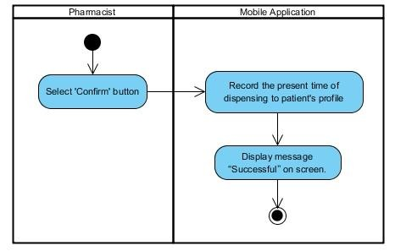

*Figure-28: Activity Diagram AD-21*

|  |  |  |  |  |  |
| --- | --- | --- | --- | --- | --- |
| **Document Name** | SMART-PRESCRIPTION-  APPLICATION- [SRS_V3.0] | **Owner** | Natthakan Kaeokanpai,  Phithiwat Sitthitun | **Page** | 55 |
| **Document Type** | Software Requirement  Specification | **Release**  **Date** | August 26th, 2016 | **Print Date** | December 9th, 2016 |

**4.2.5 Feature#5: Allergy report system**

UC-22: Doctors can create an allergy reports on the web application by inputting personal id, name, surname and allergy drug.

|  |  |  |  |  |  |  |
| --- | --- | --- | --- | --- | --- | --- |
| **Use Case ID** | | **UC-22** | | | | |
| Use Case Name: | | Doctors can create an allergy reports on the web application by  inputting personal id, name, surname, and allergy drug. | | | | |
| Actor: | | Doctors | | | | |
| Description: | | Doctors create an allergy reports to the database by inputting  personal id, name, surname, and allergy drug on the allergy report form. | | | | |
| Trigger: | | Doctors select ‘Create Allergy Report’ button on the allergy options  menu box. | | | | |
| Pre-conditions: | |  | Doctor log in by using the doctor's side. | |  | |
| Post-condition: | | System displays an allergy report. | | | | |
| **Use case input** | | | | | | |
| **Input** | **Type** | | | **Constraints** | | **Example** |
| personal ID | Int | | | Number 13 digits | | 1600100485726 |
| name | String | | | Alphabetic 30 digits | | Natthakan |
| surname | String | | | Alphabetic 30 digits | | Kaeokanpai |
| allergy report | String | | | Alphabetic or number 300 digits | | Parasetamol |
| Normal Flows: | | 1. Doctors input the information of allergy report.  2. Doctors select ‘Create’ button.  3. System verifies an allergy report create form.  4. System store name of reporter and created date time.  5. System creates an allergy report to database.  6. System displays an allergy report. | | | | |
| Alternative Flows: | | 3(A).  1. If doctors did not input the personal id field.  2. System displays error message “Personal ID cannot be blank”.  3. System works on the 6th step of normal flows.  3(B).  1. If doctors input the personal id of the patient’s profile that  already exist in the database.  2. System displays error message “Personal ID has already been exist”.  3. System works on the 6th step of normal flows.  3(C).  1. If doctors input the personal id that not follow by the constraints on the table.  2. System displays error message “Personal ID is invalid”.  3. System works on the 6th step of normal flows.  3(D).  1. If doctors did not input the name field.  2. System displays error message “Name cannot be blank”.  3. System works on the 6th step of normal flows.  3(E).  1. If doctors did not input the surname field.  2. System displays error message “Surname cannot be blank”. | | | | |

|  |  |  |  |  |  |
| --- | --- | --- | --- | --- | --- |
| **Document Name** | SMART-PRESCRIPTION-  APPLICATION- [SRS_V3.0] | **Owner** | Natthakan Kaeokanpai,  Phithiwat Sitthitun | **Page** | 56 |
| **Document Type** | Software Requirement  Specification | **Release**  **Date** | August 26th, 2016 | **Print Date** | December 9th, 2016 |

|  |  |
| --- | --- |
|  | 3. System works on the 6th step of normal flows.  3(F).  1. If doctors did not input the allergy drug field.  2. System displays error message “Allergy drug cannot be  blank”.  3. System works on the 6th step of normal flows.  3(I).  1. If doctors input the name not follow by the constraints on the table.  2. System displays error message “Name is invalid”.  3. System works on the 6th step of normal flows.  3(J).  1. If doctors input the surname not follow by the constraints on the table.  2. System displays error message “Surname is invalid”.  3. System works on the 6th step of normal flows. |
| Exceptions: | N/A |

|  |  |  |  |  |  |
| --- | --- | --- | --- | --- | --- |
| **Document Name** | SMART-PRESCRIPTION-  APPLICATION- [SRS_V3.0] | **Owner** | Natthakan Kaeokanpai,  Phithiwat Sitthitun | **Page** | 57 |
| **Document Type** | Software Requirement  Specification | **Release**  **Date** | August 26th, 2016 | **Print Date** | December 9th, 2016 |

**Activity Diagram:(AD-22):**

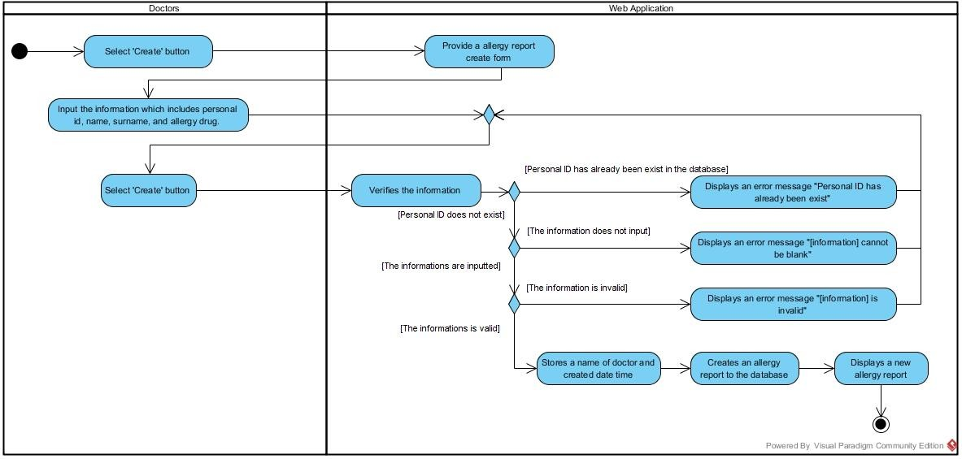

*Figure-29: Activity Diagram AD-22*

|  |  |  |  |  |  |
| --- | --- | --- | --- | --- | --- |
| **Document Name** | SMART-PRESCRIPTION-  APPLICATION- [SRS_V3.0] | **Owner** | Natthakan Kaeokanpai,  Phithiwat Sitthitun | **Page** | 58 |
| **Document Type** | Software Requirement  Specification | **Release**  **Date** | August 26th, 2016 | **Print Date** | December 9th, 2016 |

UC-23: Doctors can update an allergy report on the web application inputting personal id, name, surname or allergy drug.

|  |  |  |  |  |
| --- | --- | --- | --- | --- |
| **Use Case ID** | | **UC-23** | | |
| Use Case Name: | | Doctors can update an allergy report on the web application  inputting personal id, name, surname or allergy drug. | | |
| Actor: | | Doctors | | |
| Description: | | Doctors update an allergy report by change the default report to a  new reports (name, surname, personal ID, and allergy drug of the allergy report). | | |
| Trigger: | | Doctors select ‘Update’ button on the options column of table. | | |
| Pre-conditions: | | Doctors have to create an allergy report before updating. | | |
| Post-condition: | | Doctors can view a new allergy report on the list of allergy report  list. | | |
| **Use case input** | | | | |
| **Input** | **Type** | | **Constraints** | **Example** |
| personal ID | Int | | Number 13 digits | 1600100485726 |
| name | String | | Alphabetic 30 digits | Natthakan |
| surname | String | | Alphabetic 30 digits | Kaeokanpai |
| allergy report | String | | Alphabetic or number or symbol | Parasetamol |
| Normal Flows: | | 1. Doctors input the information of allergy report.  2. Doctors select ‘save’ button.  3. System verifies an allergy report update form.  4. System store name of reporter and updated date time.  5. System creates an allergy report to database.  6. System displays an allergy report. | | |
| Alternative Flows: | | 3(A).  1. If doctors did not input the personal id field.  2. System displays error message “Personal ID cannot be  blank”.  3. System works on the 6th step of normal flows.  3(B).  1. If doctors input the personal id of the patient’s profile that  already exist in the database.  2. System displays error message “Personal ID has already been exist”.  3. System works on the 6th step of normal flows.  3(C).  1. If doctors input the personal id that not follow by the constraints on the table.  2. System displays error message “Personal ID is invalid”.  3. System works on the 6th step of normal flows.  3(D).  1. If doctors did not input the name field.  2. System displays error message “Name cannot be blank”.  3. System works on the 6th step of normal flows.  3(E).  1. If doctors did not input the surname field.  2. System displays error message “Surname cannot be blank”.  3. System works on the 6th step of normal flows.  3(F).  1. If doctors did not input the allergy drug field.  2. System displays error message “Allergy drug cannot be blank”. | | |

|  |  |  |  |  |  |
| --- | --- | --- | --- | --- | --- |
| **Document Name** | SMART-PRESCRIPTION-  APPLICATION- [SRS_V3.0] | **Owner** | Natthakan Kaeokanpai,  Phithiwat Sitthitun | **Page** | 59 |
| **Document Type** | Software Requirement  Specification | **Release**  **Date** | August 26th, 2016 | **Print Date** | December 9th, 2016 |

|  |  |
| --- | --- |
|  | 3. System works on the 6th step of normal flows.  3(I).  1. If doctors input the name not follow by the constraints on the table.  2. System displays error message “Name is invalid”.  3. System works on the 6th step of normal flows.  3(J).  1. If doctors input the surname not follow by the constraints on the table.  2. System displays error message “Surname is invalid”.  3. System works on the 6th step of normal flows. |
| Exceptions: | N/A |

|  |  |  |  |  |  |
| --- | --- | --- | --- | --- | --- |
| **Document Name** | SMART-PRESCRIPTION-  APPLICATION- [SRS_V3.0] | **Owner** | Natthakan Kaeokanpai,  Phithiwat Sitthitun | **Page** | 60 |
| **Document Type** | Software Requirement  Specification | **Release**  **Date** | August 26th, 2016 | **Print Date** | December 9th, 2016 |

**Activity Diagram:(AD-23):**

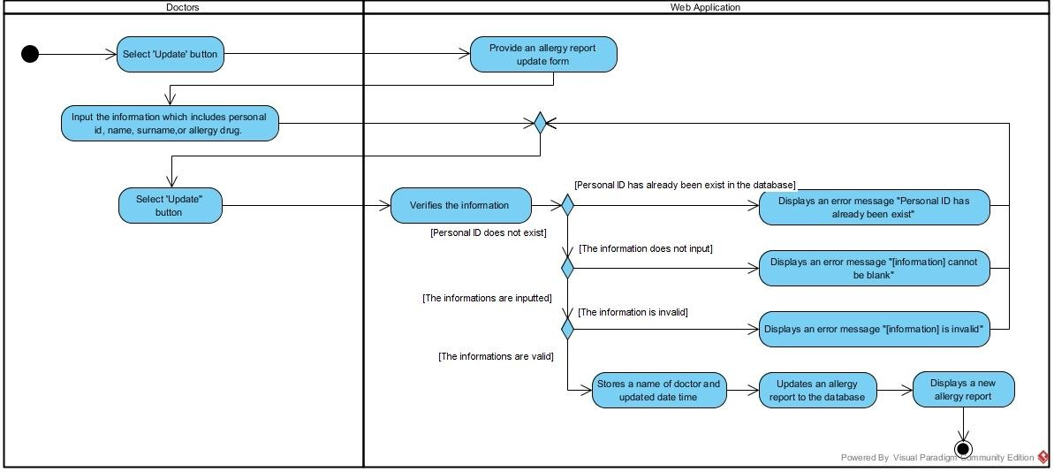

*Figure-30: Activity Diagram AD-23*

|  |  |  |  |  |  |
| --- | --- | --- | --- | --- | --- |
| **Document Name** | SMART-PRESCRIPTION-  APPLICATION- [SRS_V3.0] | **Owner** | Natthakan Kaeokanpai,  Phithiwat Sitthitun | **Page** | 61 |
| **Document Type** | Software Requirement  Specification | **Release**  **Date** | August 26th, 2016 | **Print Date** | December 9th, 2016 |

UC-24: Doctor can delete an allergy report on the web application.

|  |  |  |  |
| --- | --- | --- | --- |
| **Use Case ID** | **UC-24** | | |
| Use Case Name: | Doctors can delete an allergy reports on the web application. | | |
| Actor: | Doctors | | |
| Description: | Doctors delete an allergy reports from the database. | | |
| Trigger: | Doctor selects ‘Delete’ button on the options column of table. | | |
| Pre-conditions: | 1. | Doctors log in by using doctor's side. |  |
| 2. Doctor access to management page. | | |
| Post-condition: | System deletes an allergy report from database. | | |
| Normal Flows: | 1. System displays the alert message “Are you sure you want  to delete this item?” with ‘Ok’ button and ‘Cancel’ button.  2. Doctors select ‘Ok’ button.  3. System deletes the allergy report from the database | | |
| Alternative Flows: | 2(A).  1. Doctors select “Cancel” button on alert message.  2. Systems are not able to delete the allergy report from the database. | | |

**Activity Diagram:(AD-24):**

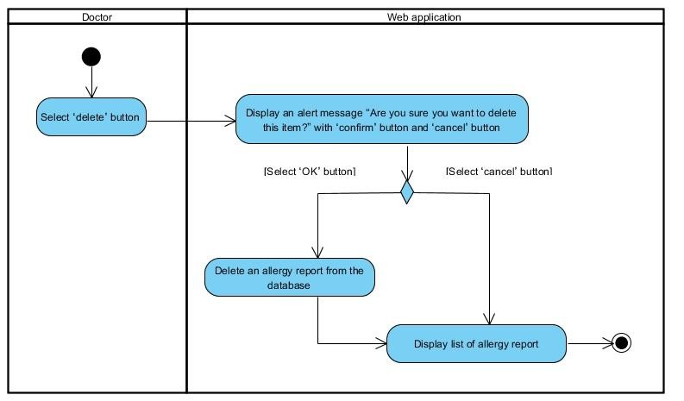

*Figure-31: Activity Diagram AD-24*

|  |  |  |  |  |  |
| --- | --- | --- | --- | --- | --- |
| **Document Name** | SMART-PRESCRIPTION-  APPLICATION- [SRS_V3.0] | **Owner** | Natthakan Kaeokanpai,  Phithiwat Sitthitun | **Page** | 62 |
| **Document Type** | Software Requirement  Specification | **Release**  **Date** | August 26th, 2016 | **Print Date** | December 9th, 2016 |

UC-25: Doctors can search an allergy reports on the web application by using personal id, name, or surname.

|  |  |  |  |  |  |  |
| --- | --- | --- | --- | --- | --- | --- |
| **Use Case ID** | | **UC-25** | | | | |
| Use Case Name: | | Doctors search an allergy reports on the web application by using  personal id, name, or surname. | | | | |
| Actor: | | Doctors | | | | |
| Description: | | Doctors search allergy reports by input personal id, name, or  surname to the search field. | | | | |
| Trigger: | | Doctors select ‘Search’ button. | | | | |
| Pre-conditions: | | 1. Doctor | | log in by using doctor's side. | |  |
| 2. Doctor access to management page. | | | | |
| Post-condition: | | System displays allergy report that match with searching from  database. | | | | |
| **Use case input** | | | | | | |
| **Input** | **Type** | **Constraints** | | | **Example of information** | |
| Keyword | String | String of alphabet or number | | | 1600100485726 | |
| Normal Flows: | | 1. | Doctors | input an allergy ID, allergy drug, or personal ID to | | |
| the search bars.  2. Doctors select ‘Search’ button.  3. System validates a keyword search.  4. System retrieves an allergy report from the database that match with a keyword search.  5. System displays an allergy report. | | | | |
| Alternative Flows: | | 3(A).  1. System displays a message “No results found” if there are no data that match with a keyword search in the database. | | | | |

**Activity Diagram:(AD-25):**

*Figure-32: Activity Diagram AD-25*

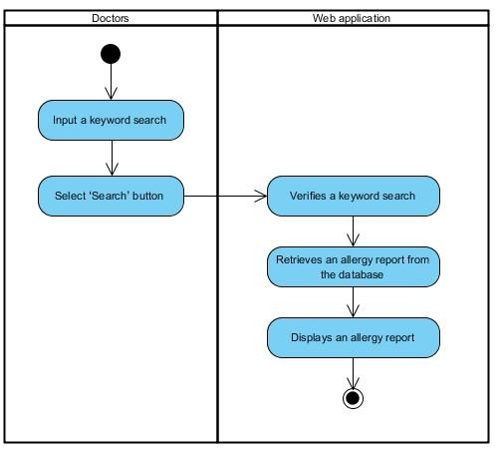

|  |  |  |  |  |  |
| --- | --- | --- | --- | --- | --- |
| **Document Name** | SMART-PRESCRIPTION-  APPLICATION- [SRS_V3.0] | **Owner** | Natthakan Kaeokanpai,  Phithiwat Sitthitun | **Page** | 63 |
| **Document Type** | Software Requirement  Specification | **Release**  **Date** | August 26th, 2016 | **Print Date** | December 9th, 2016 |

UC-26: Doctors can view an allergy reports on the web application.

|  |  |  |  |
| --- | --- | --- | --- |
| **Use Case ID** | **UC-26** | | |
| Use Case Name: | Doctors can view an allergy reports on the web application | | |
| Actor: | Doctors | | |
| Description: | Doctors view an allergy reports on a list of allergy reports. | | |
| Trigger: | Doctors select “View” button on the options column of table. | | |
| Pre-conditions: | 1. | Doctor log in by using the doctor's side. |  |
| 2. Doctor access to management page. | | |
| Post-condition: | Doctors view the information of allergy reports. | | |
| Normal Flows: | 1. System retrieves an allergy reports from the database.  2. System displays the information of allergy reports. | | |
| Exceptions: | 1. Systems are not display an allergy report if there are no  allergy reports in the database. | | |

**Activity Diagram:(AD-26):**

*Figure-33: Activity Diagram AD-26*

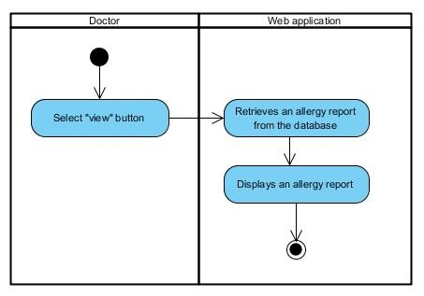

|  |  |  |  |  |  |
| --- | --- | --- | --- | --- | --- |
| **Document Name** | SMART-PRESCRIPTION-  APPLICATION- [SRS_V3.0] | **Owner** | Natthakan Kaeokanpai,  Phithiwat Sitthitun | **Page** | 64 |
| **Document Type** | Software Requirement  Specification | **Release**  **Date** | August 26th, 2016 | **Print Date** | December 9th, 2016 |

UC-27: Doctors can view a list of allergy reports on the web application.

|  |  |  |  |
| --- | --- | --- | --- |
| **Use Case ID** | **UC-27** | | |
| Use Case Name: | Doctors can view a list of allergy reports on the web application. | | |
| Actor: | Doctors | | |
| Description: | Doctors view list of all allergy reports. | | |
| Trigger: | Doctors select “Manage Allergy Reports” button on the allergy  options menu box. | | |
| Pre-conditions: |  | Doctors need to log in by using doctor's side. |  |
| Post-condition: | Doctors view a list of all allergy reports. | | |
| Normal Flows: | 1. System retrieves all allergy reports from the database.  2. System provides a list of allergy report. | | |
| Exceptions: | 1. Systems are not display list of allergy reports if there are no  allergy reports. | | |
| Includes: | N/A | | |
| Notes and Issues: | N/A | | |

**Activity Diagram:(AD-27):**

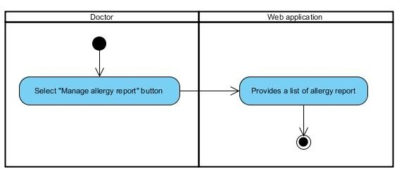

*Figure-34: Activity Diagram AD-*27

|  |  |  |  |  |  |
| --- | --- | --- | --- | --- | --- |
| **Document Name** | SMART-PRESCRIPTION-  APPLICATION- [SRS_V3.0] | **Owner** | Natthakan Kaeokanpai,  Phithiwat Sitthitun | **Page** | 65 |
| **Document Type** | Software Requirement  Specification | **Release**  **Date** | August 26th, 2016 | **Print Date** | December 9th, 2016 |

**4.2.1 Feature#6: Summary allergy report**

UC-28 FDAs view a FDAs home page on the web application.

**Use Case ID UC-28**

Use Case Name: FDAs can view a FDAs home page on the web application. Actor: FDAs

Description: FDAs can view a FDAs home page on the web application after login

successful.

Trigger: FDAs log in to the web application by using the FDA's side. Pre-conditions: 1. Administration already created the FDA’s profile.

2. FDAs already login to the web application.

Post-condition: FDAs scan view the information of FDA on home page.

Normal Flows: 1. System provides the information of the FDA home page.

**Activity Diagram :( AD-28):**

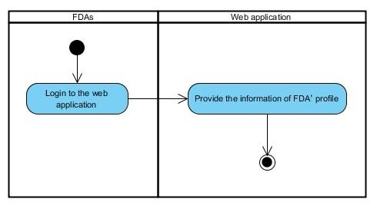

*Figure-35: Activity Diagram AD-28*

|  |  |  |  |  |  |
| --- | --- | --- | --- | --- | --- |
| **Document Name** | SMART-PRESCRIPTION-  APPLICATION- [SRS_V3.0] | **Owner** | Natthakan Kaeokanpai,  Phithiwat Sitthitun | **Page** | 66 |
| **Document Type** | Software Requirement  Specification | **Release**  **Date** | August 26th, 2016 | **Print Date** | December 9th, 2016 |

UC-29: FDAs can view allergy reports on the web application.

|  |  |  |  |
| --- | --- | --- | --- |
| **Use Case ID** | **UC-29** | | |
| Use Case Name: | FDAs can view an allergy report on the web application. | | |
| Actor: | FDAs | | |
| Description: | FDAs view an allergy reports on a list of allergy reports. | | |
| Trigger: | FDAs select “View” button on the options column of table. | | |
| Pre-conditions: |  | FDAs log in by using the FDA's side. |  |
| Post-condition: | FDAs view the information of allergy reports. | | |
| Normal Flows: | 1. System retrieves an allergy reports from the database.  2. System displays the information of allergy reports. | | |
| Exceptions: | 1. Systems are not display an allergy report if there are no  allergy reports in the database. | | |

**Activity Diagram:(AD-29):**

*Figure-36: Activity Diagram AD-29*

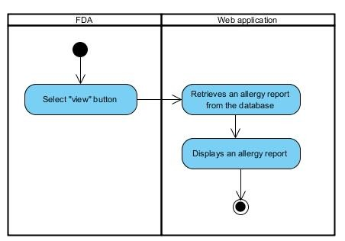

|  |  |  |  |  |  |
| --- | --- | --- | --- | --- | --- |
| **Document Name** | SMART-PRESCRIPTION-  APPLICATION- [SRS_V3.0] | **Owner** | Natthakan Kaeokanpai,  Phithiwat Sitthitun | **Page** | 67 |
| **Document Type** | Software Requirement  Specification | **Release**  **Date** | August 26th, 2016 | **Print Date** | December 9th, 2016 |

UC-30: FDA can view a list of allergy report on the web application.

|  |  |  |  |  |  |
| --- | --- | --- | --- | --- | --- |
| **Use Case ID** | **UC-30** | | | | |
| Use Case Name: | FDAs can view a list of allergy reports on the web application. | | | | |
| Actor: | FDAs | | | | |
| Description: | FDAs view a list of all allergy reports. | | | | |
| Trigger: | FDAs select “View Report Lists” button on the options menu box. | | | | |
| Pre-conditions: | FDAs | need to log in by using | FDA | 's side. |  |
| Post-condition: | FDAs view a list of all allergy reports. | | | | |
| Normal Flows: | 1. System retrieves all allergy reports from the database.  2. System provides a list of allergy report. | | | | |
| Exceptions: | System does not display a list of allergy report if there are no allergy  reports. | | | | |

**Activity Diagram:(AD-30):**

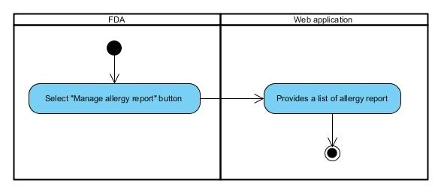

*Figure-37: Activity Diagram AD-30*

|  |  |  |  |  |  |
| --- | --- | --- | --- | --- | --- |
| **Document Name** | SMART-PRESCRIPTION-  APPLICATION- [SRS_V3.0] | **Owner** | Natthakan Kaeokanpai,  Phithiwat Sitthitun | **Page** | 68 |
| **Document Type** | Software Requirement  Specification | **Release**  **Date** | August 26th, 2016 | **Print Date** | December 9th, 2016 |

**Chapter Five | References**

[1] Definition of User Interface. <http://searchsoa.techtarget.com/definition/user-interface>

[2] Definition of Use Case Diagram. <http://en.wikipedia.org/wiki/Use_Case_Diagram>

[3] Definition of Activity Diagram. <http://en.wikipedia.org/wiki/Activity_diagram>

|  |  |  |  |  |  |
| --- | --- | --- | --- | --- | --- |
| **Document Name** | SMART-PRESCRIPTION-  APPLICATION- [SRS_V3.0] | **Owner** | Natthakan Kaeokanpai,  Phithiwat Sitthitun | **Page** | 69 |
| **Document Type** | Software Requirement  Specification | **Release**  **Date** | August 26th, 2016 | **Print Date** | December 9th, 2016 |